**Project : Capstone I**

You have been hired as a Sr. DevOps Engineer in Abode Software. They want to

implement DevOps Lifecycle in their company. You have been asked to

implement this lifecycle as fast as possible. Abode Software is a product-based

company and their product is available on this GitHub link.

https://github.com/hshar/website.git

Following are the specifications of the lifecycle:

1. Install the necessary software on the machines using a configuration

management tool

2. Git workflow has to be implemented

3. CodeBuild should automatically be triggered once a commit is made to

master branch or develop branch.

a. If a commit is made to master branch, test and push to prod

b. If a commit is made to develop branch, just test the product, do not

push to prod

4. The code should be containerized with the help of a Dockerfile. The

Dockerfile should be built every time there is a push to GitHub. Use the

following pre-built container for your application: hshar/webapp

The code should reside in '/var/www/html'

5. The above tasks should be defined in a Jenkins Pipeline with the following

jobs:

a. Job1 : build

b. Job2 : test

c. Job3 : prod

Solution:

creating master VM

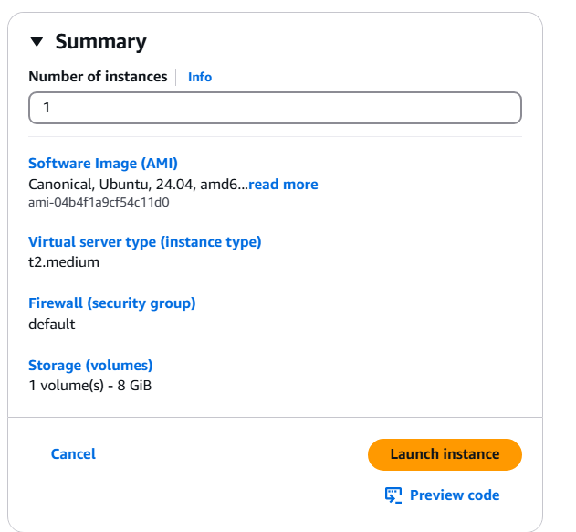

Created 2 instances for test and prod

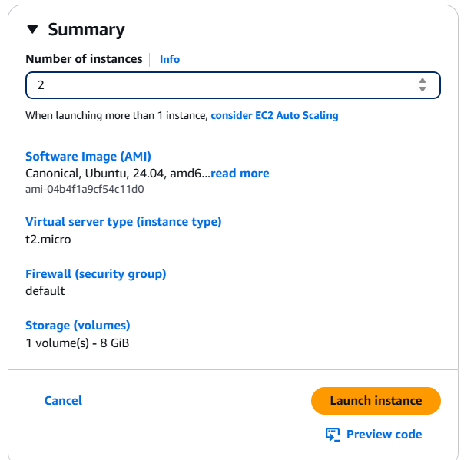

Updating the all machine

Sudo apt update

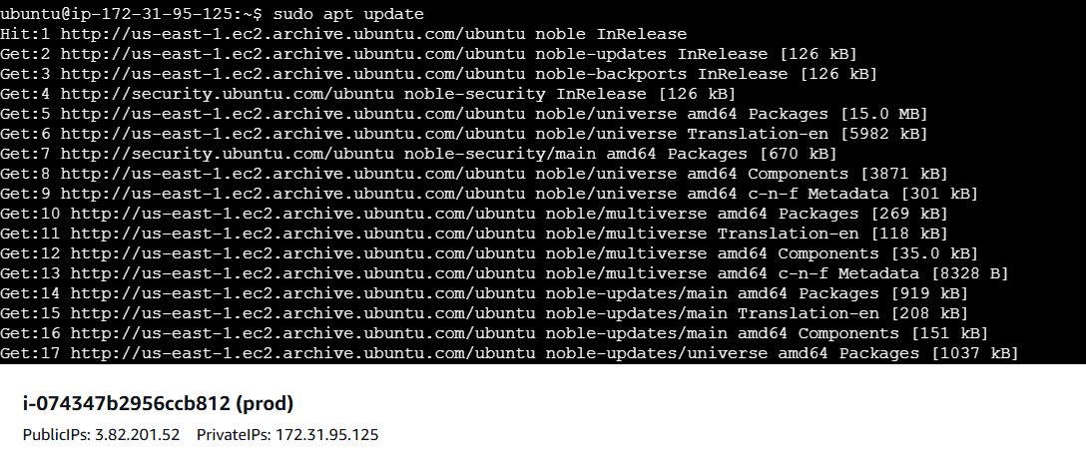 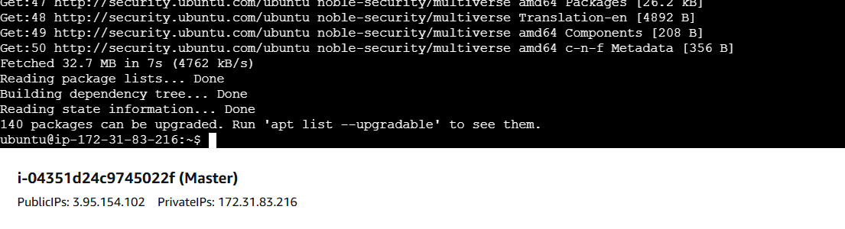

**Installing Ansible on master instance**

sudo apt install software-properties-common

sudo add-apt-repository --yes --update ppa:ansible/ansible

sudo apt install ansible

**Creating key to establish the cluster**

Ssh-keygen

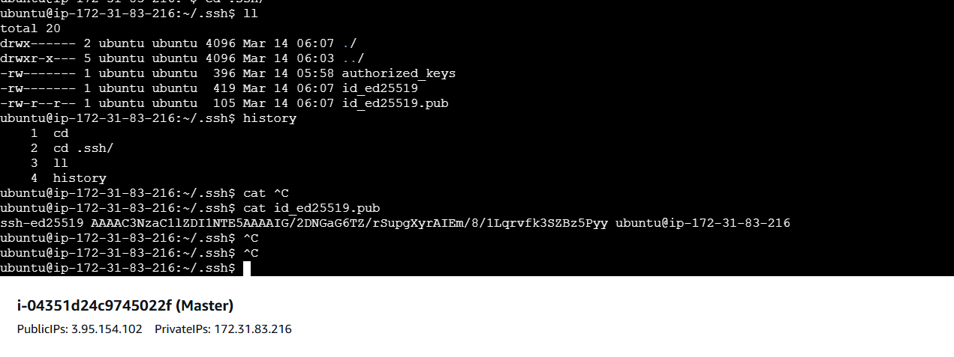

Copy the public key and add into authorized keys of test and prod instance

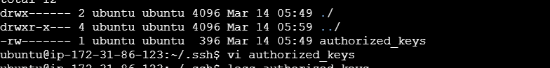

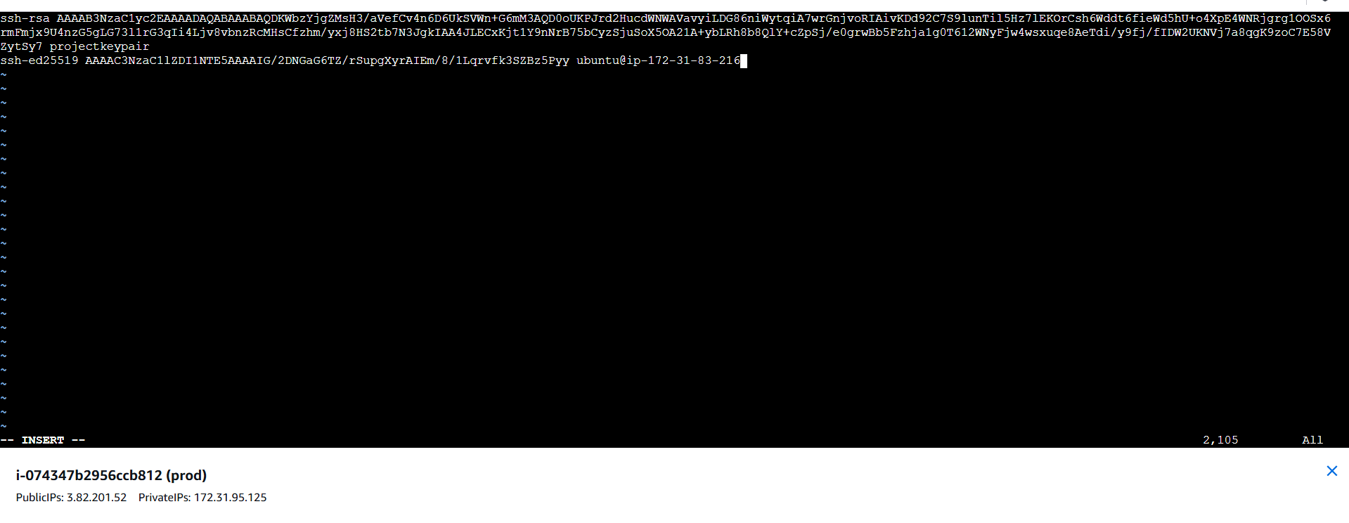

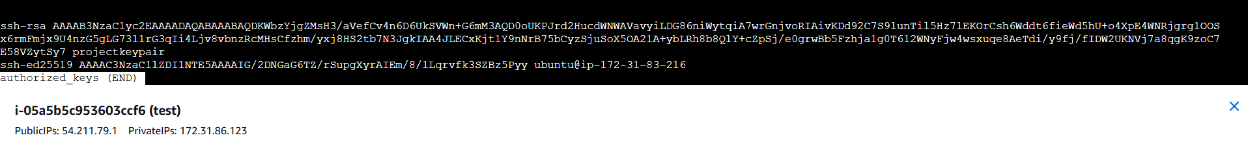

**Enter private IP of prod and test server in hosts under /etc/ansible**

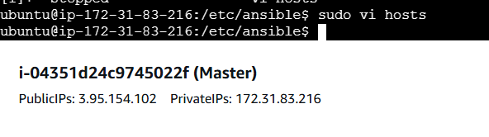

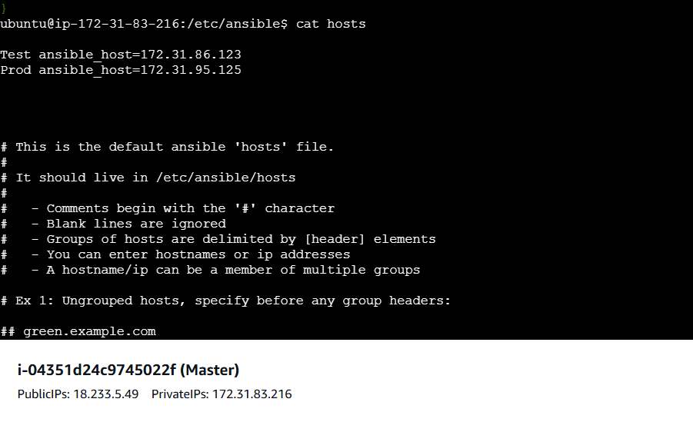

Now able to connect to test and prod

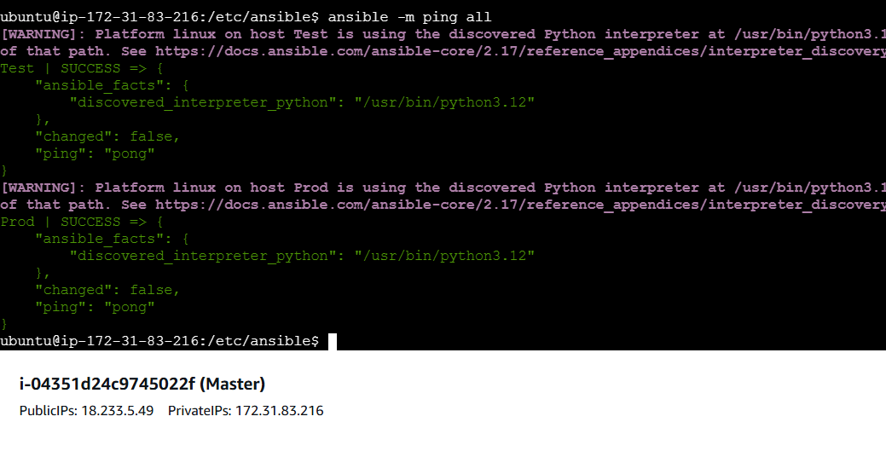

Create master.sh and slave.sh to install the jenkins , java on master and java ,docker on slave instances(test and prod instance)

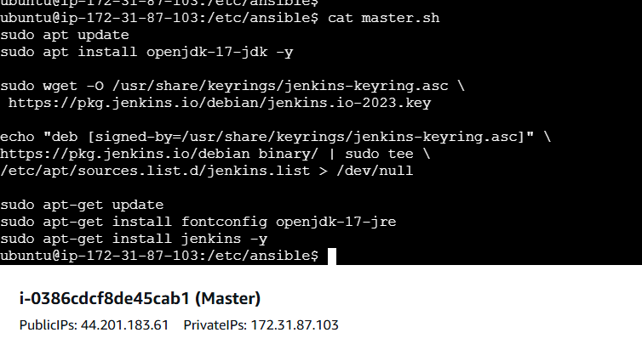

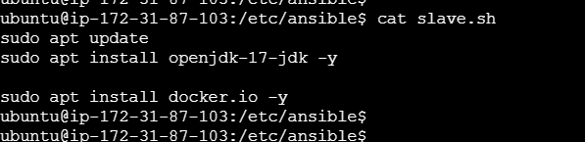

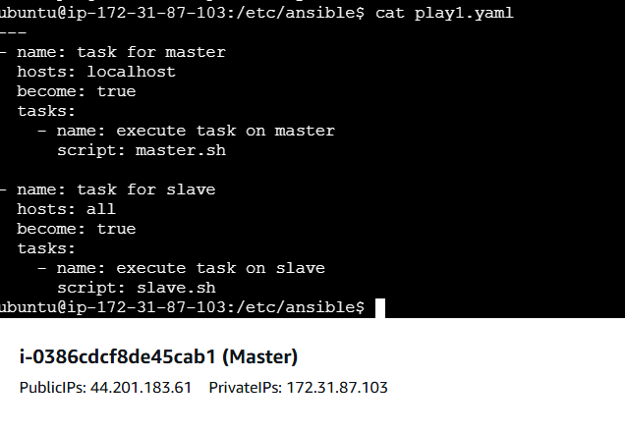

**Run below commands to verify syntax and run playbook**

ansible-playbook play1.yaml --syntax-check

ansible-playbook play1.yaml --check

ansible-playbook play1.yaml

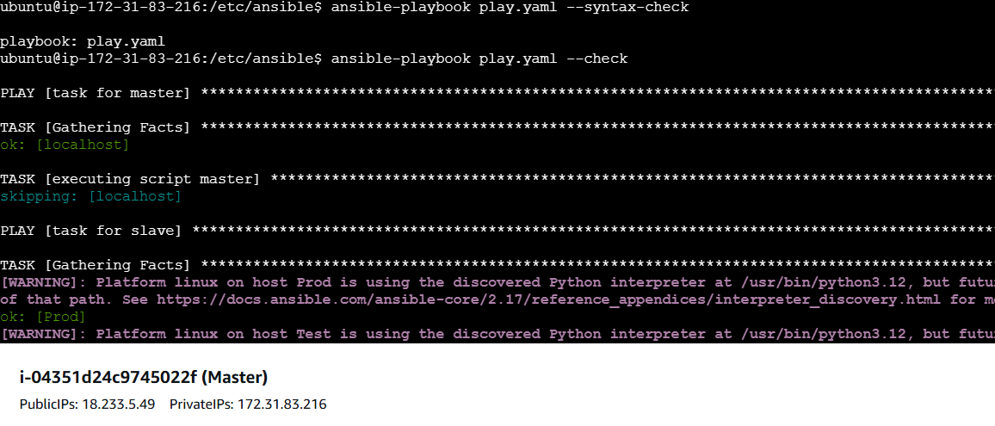

Run the playbook

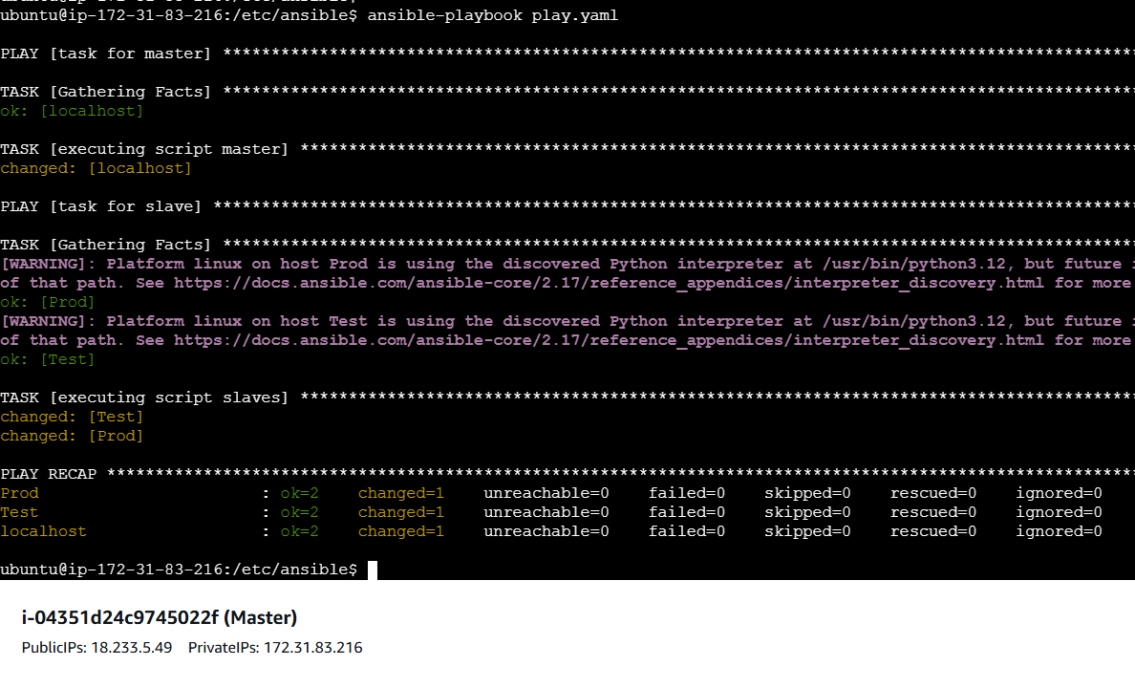

Jave installed successfully on master and slave machine

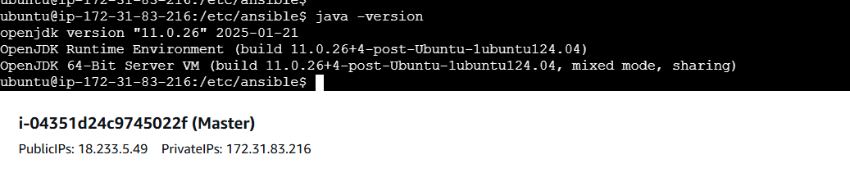

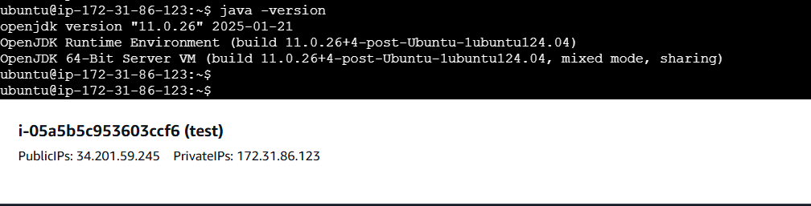

Take public Ip of the master and port 8080 to open jenkins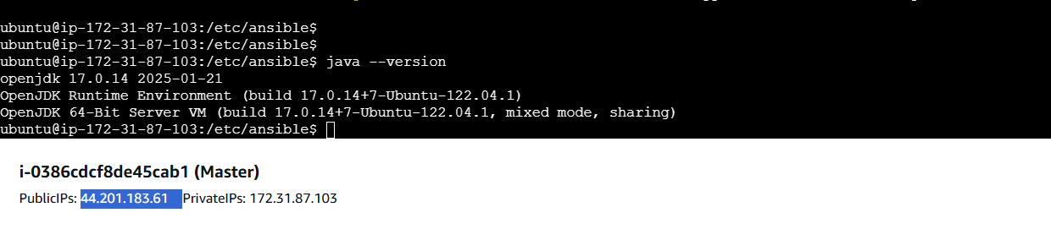

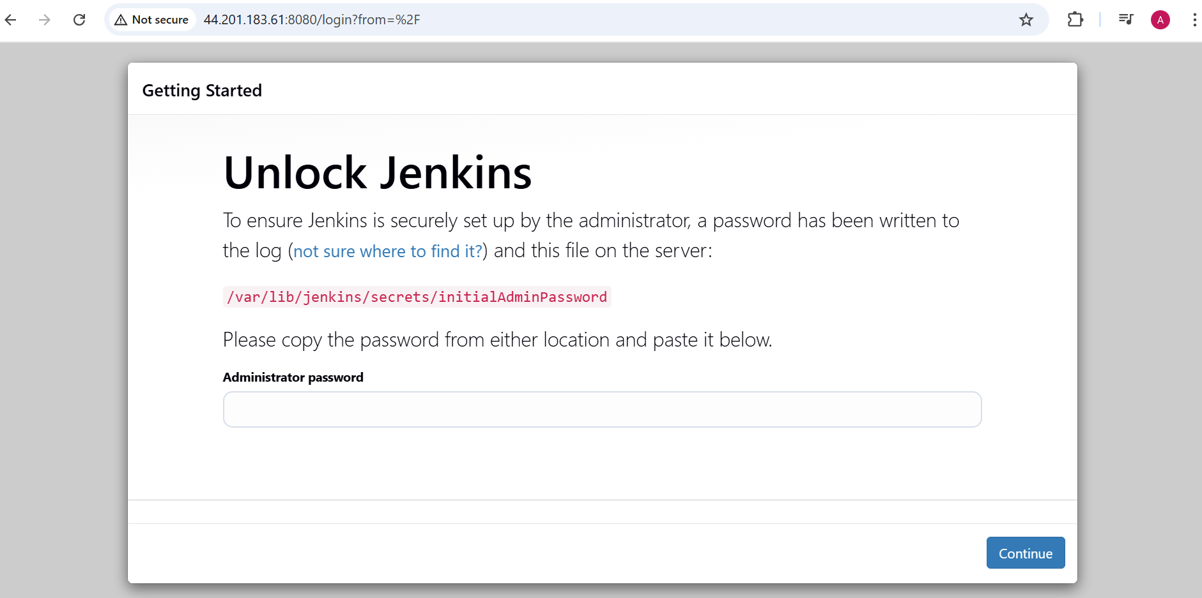

Take the initial password

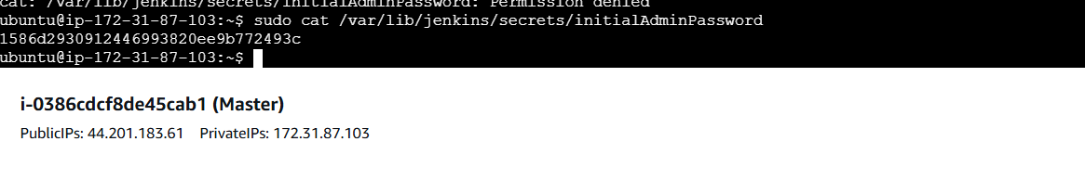

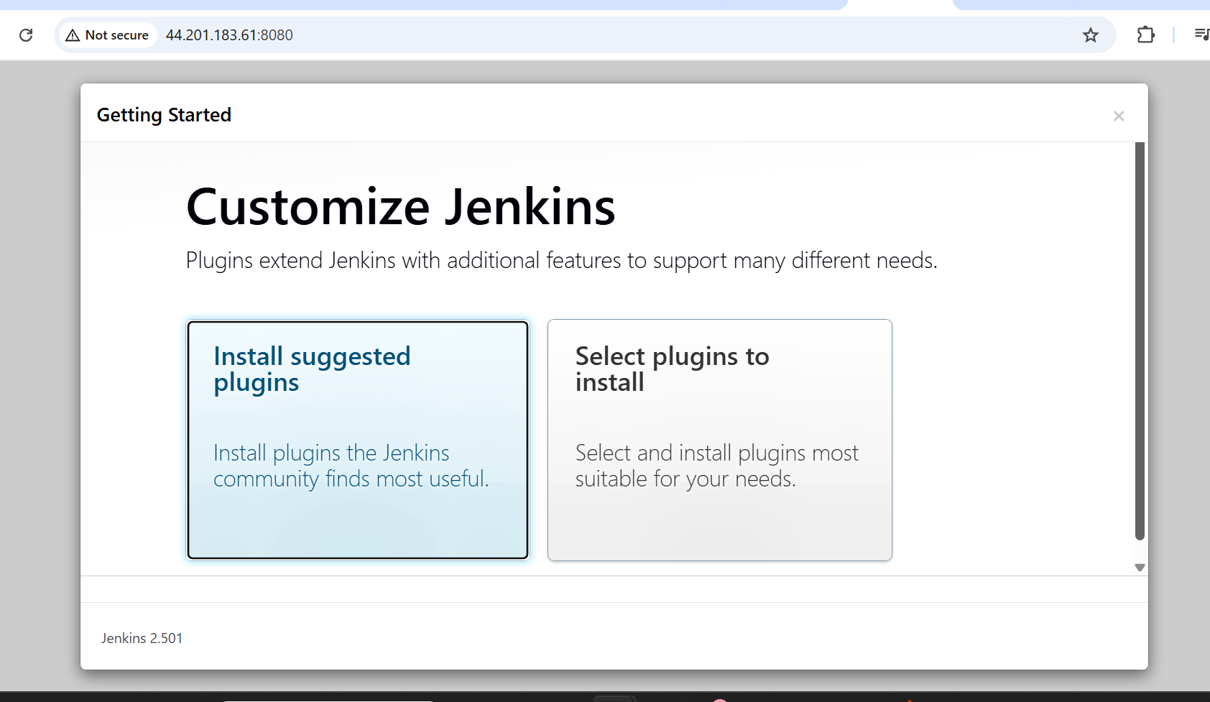

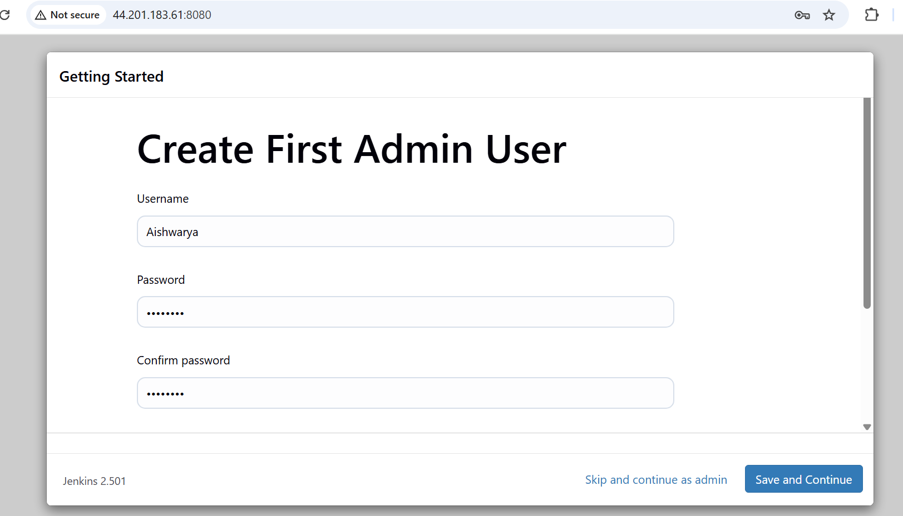

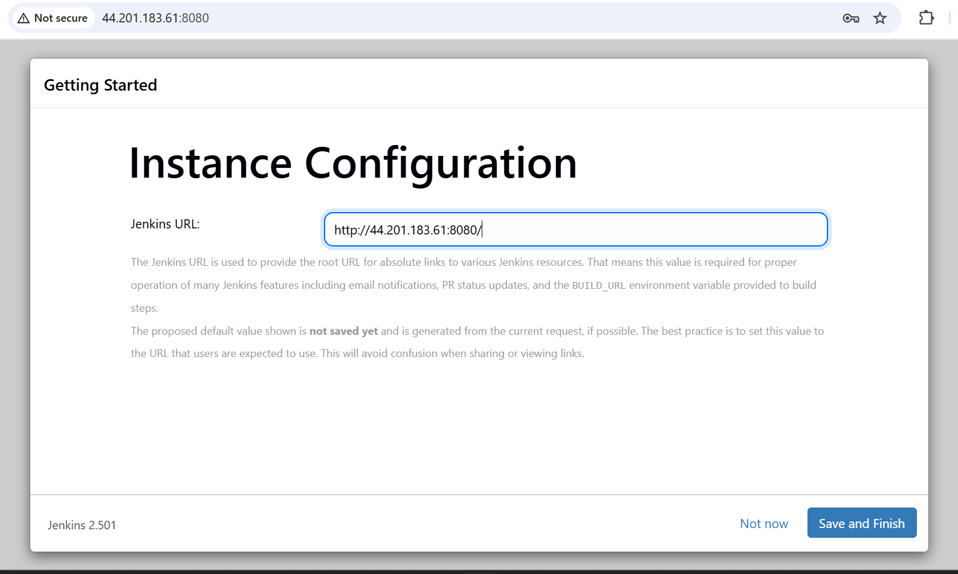

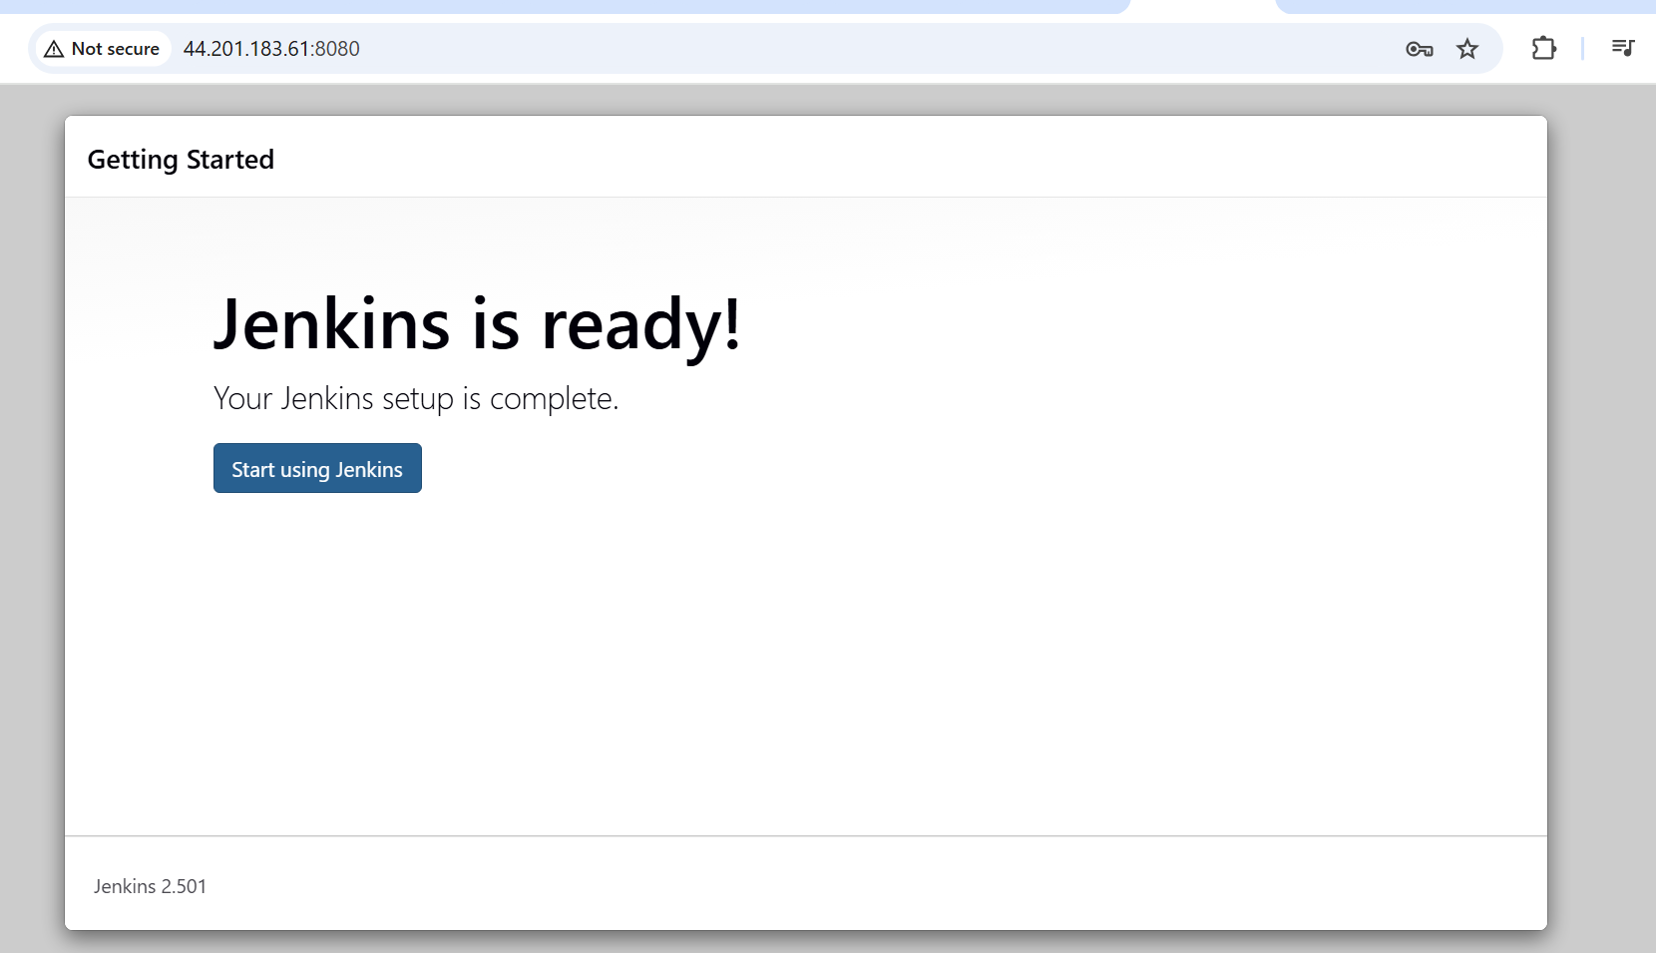

Go to manage jenkins

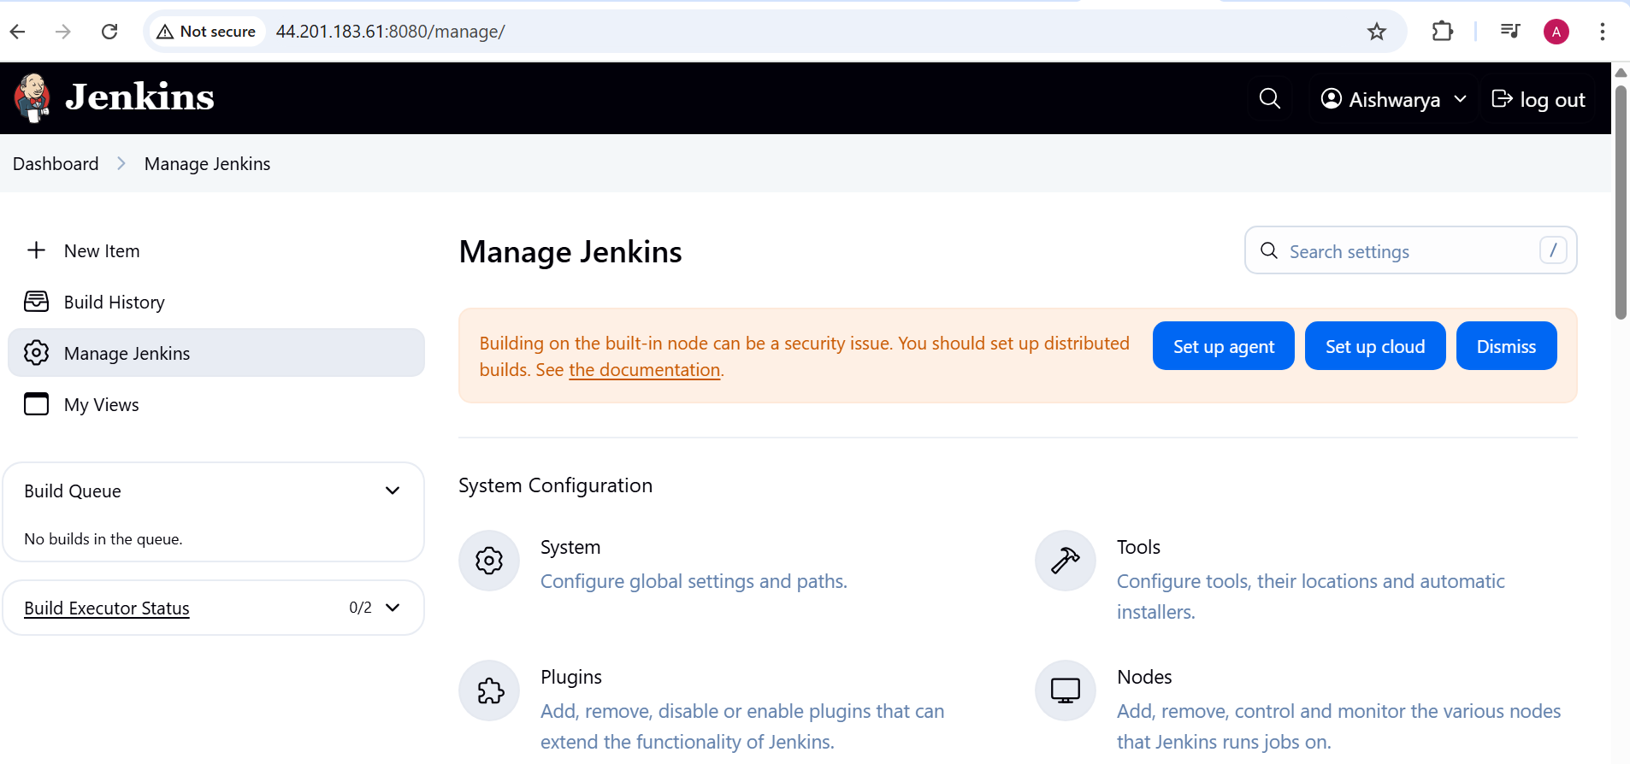

Security

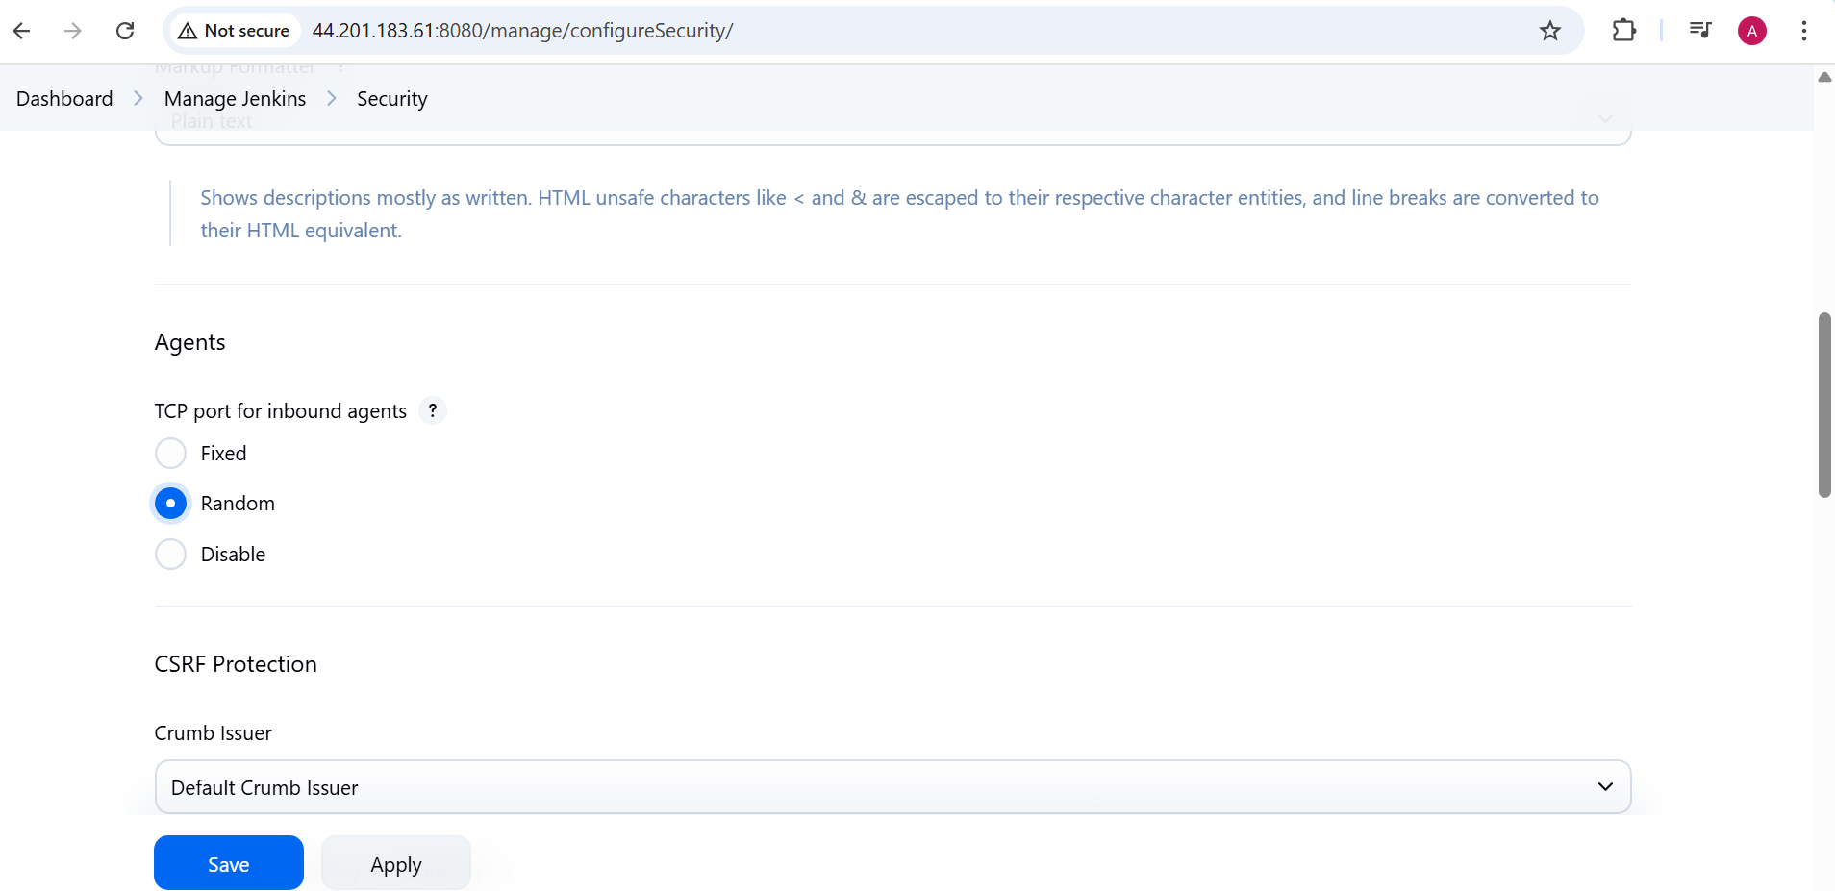

Now install necessary plugins

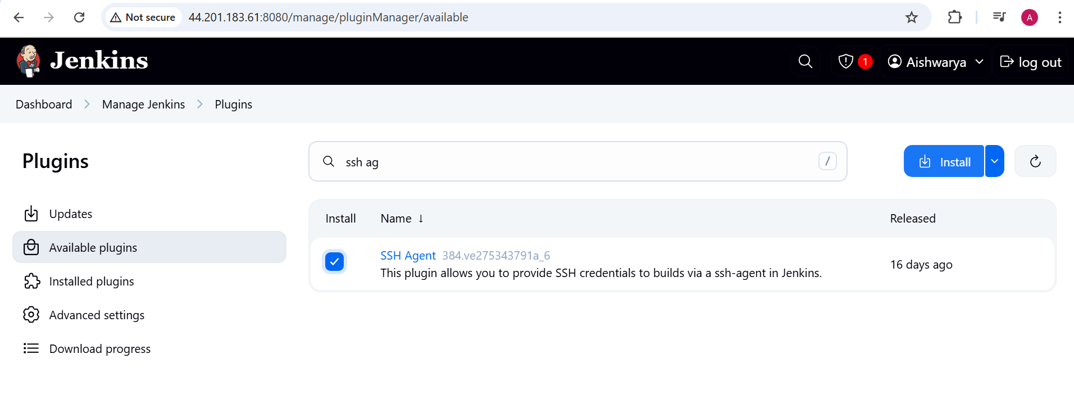

Now setup the agent:

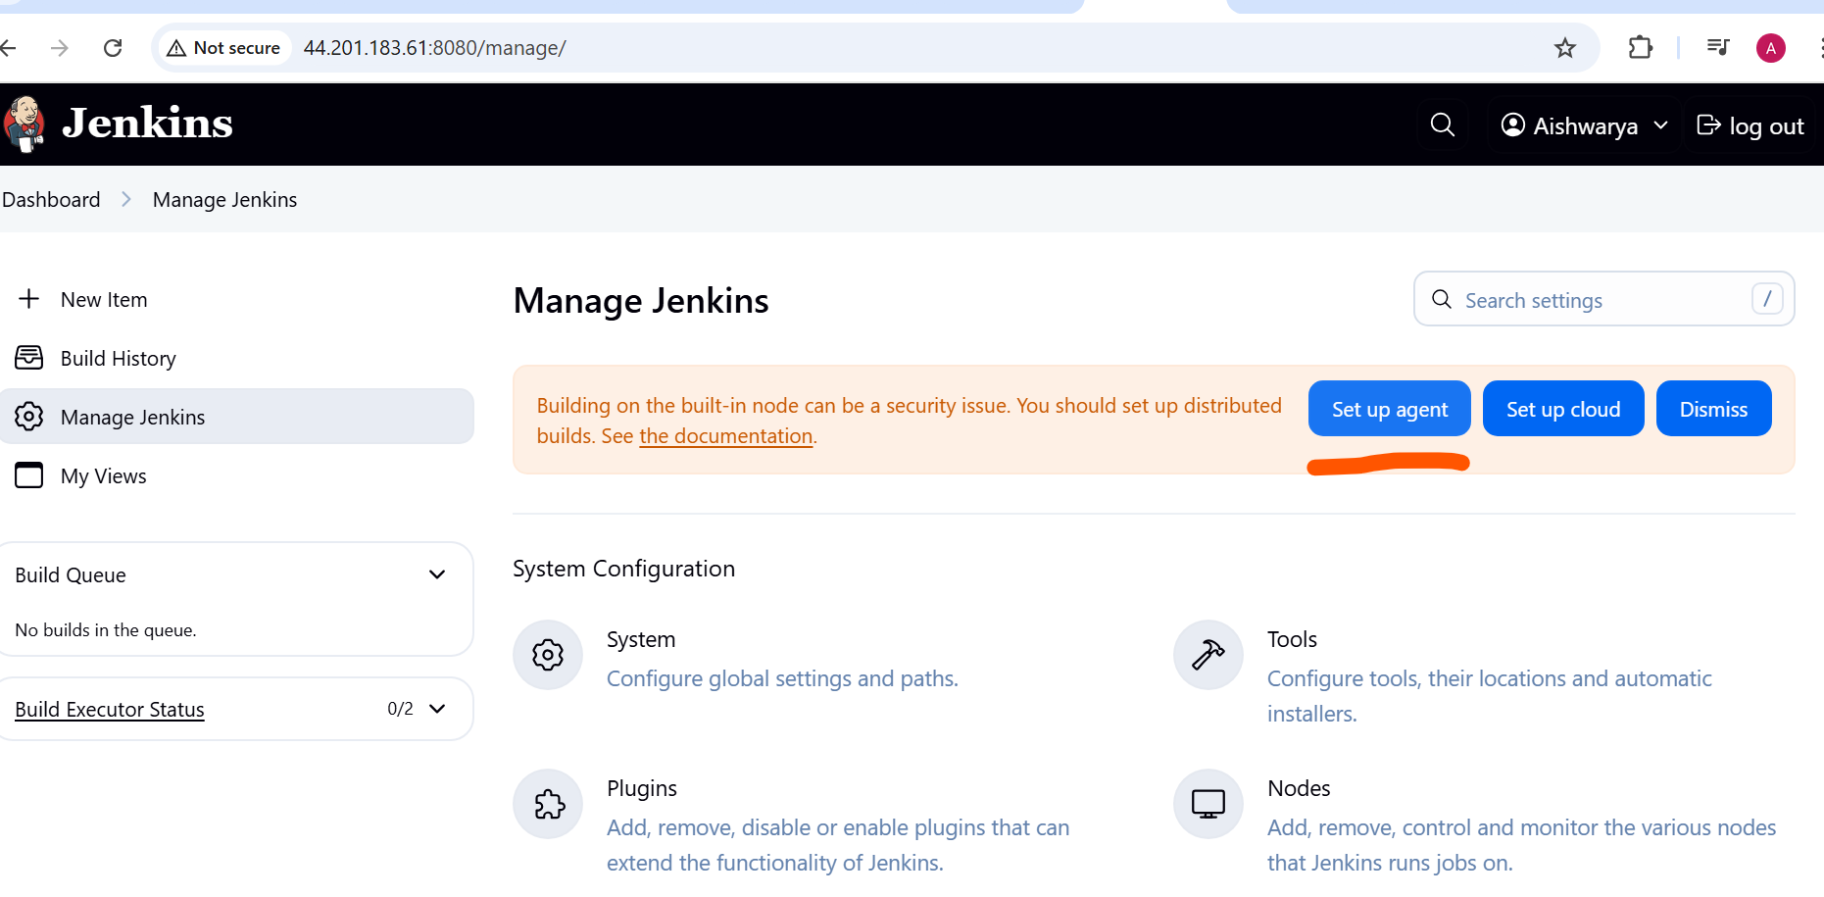

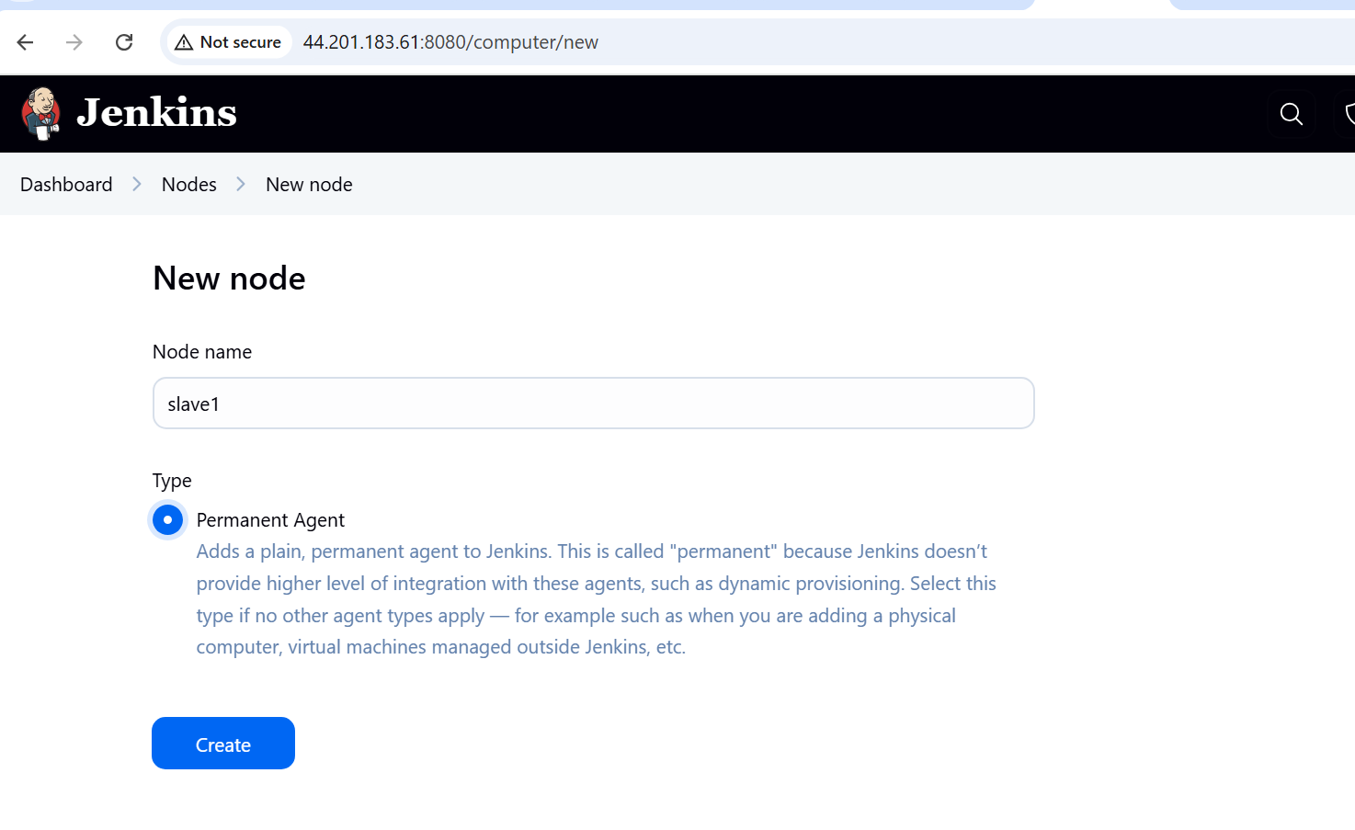

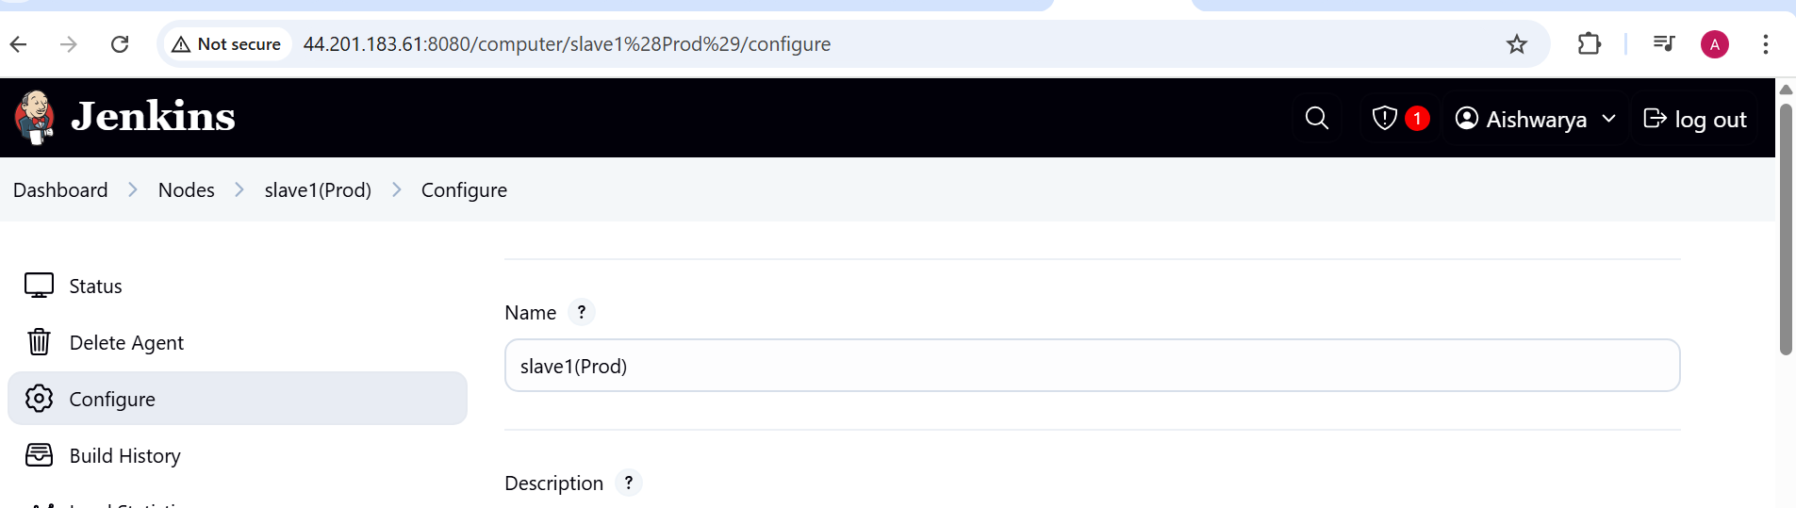

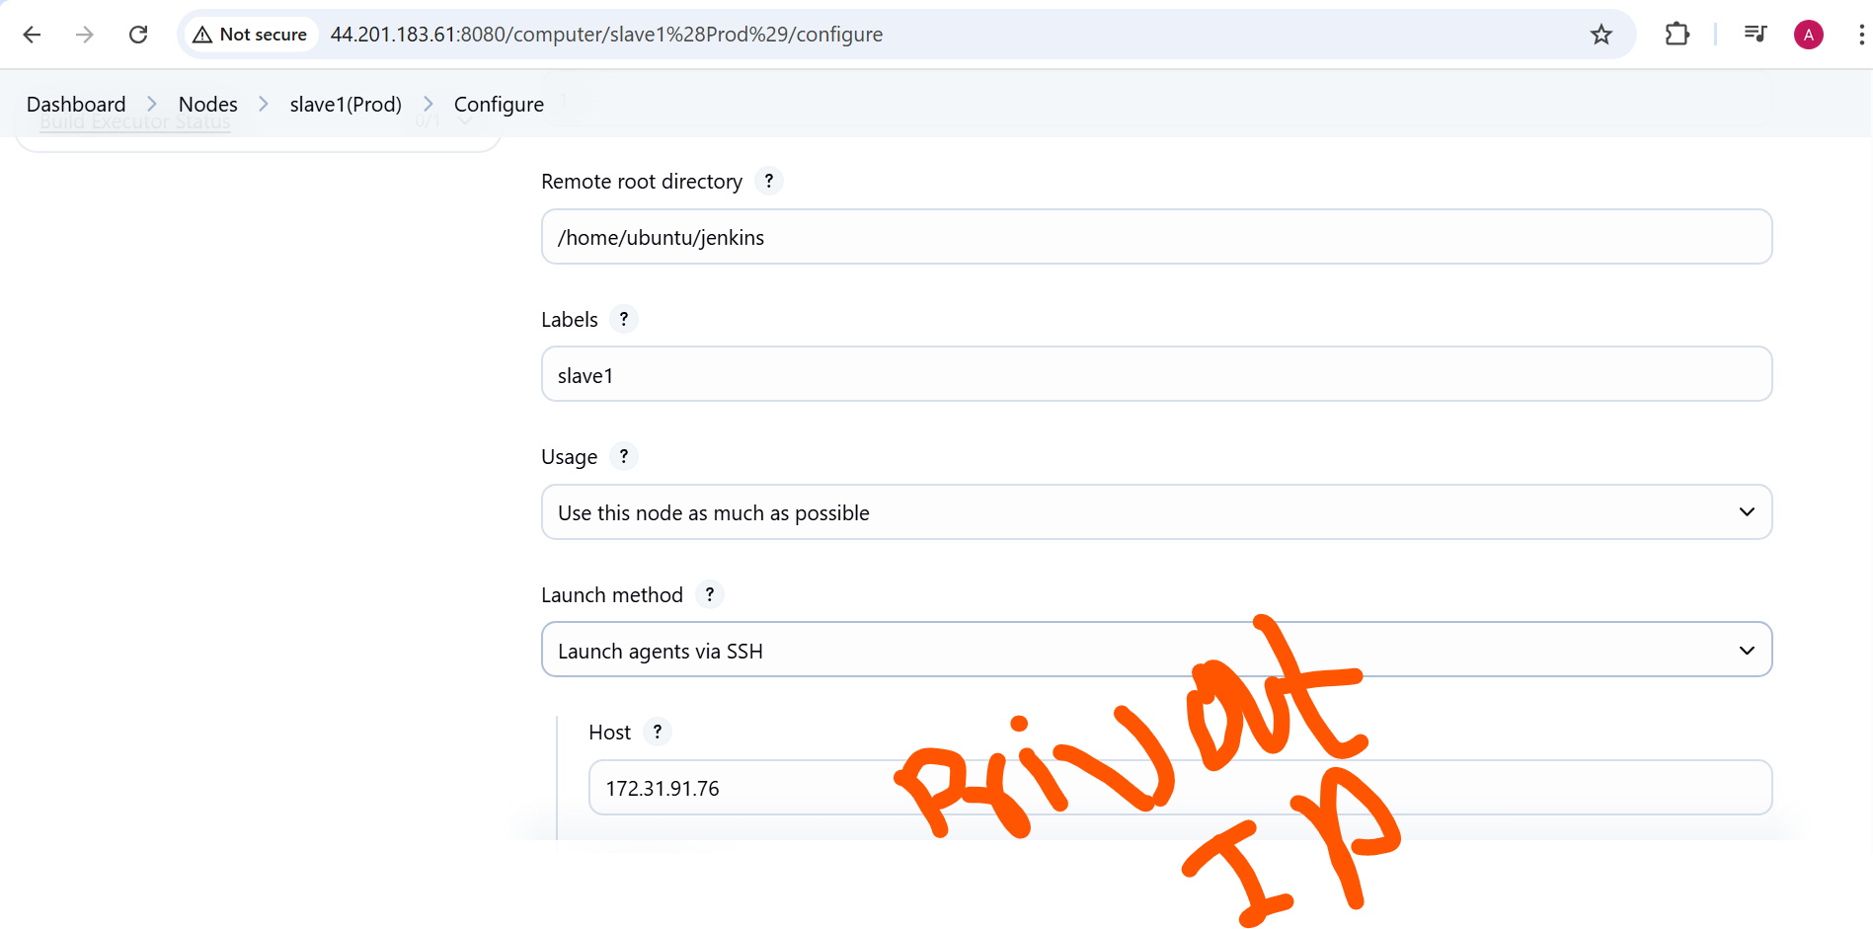

Create credential

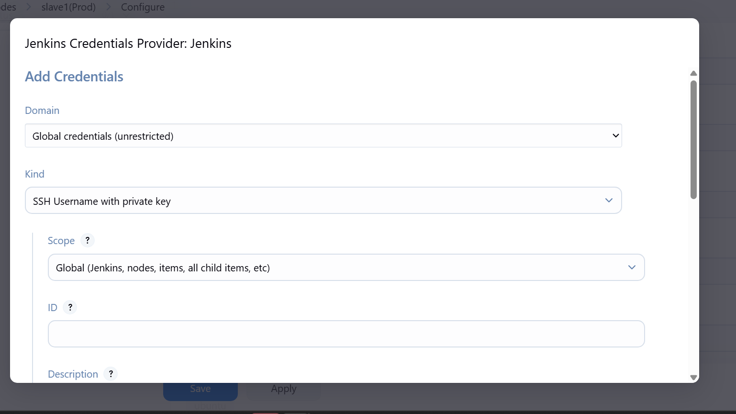

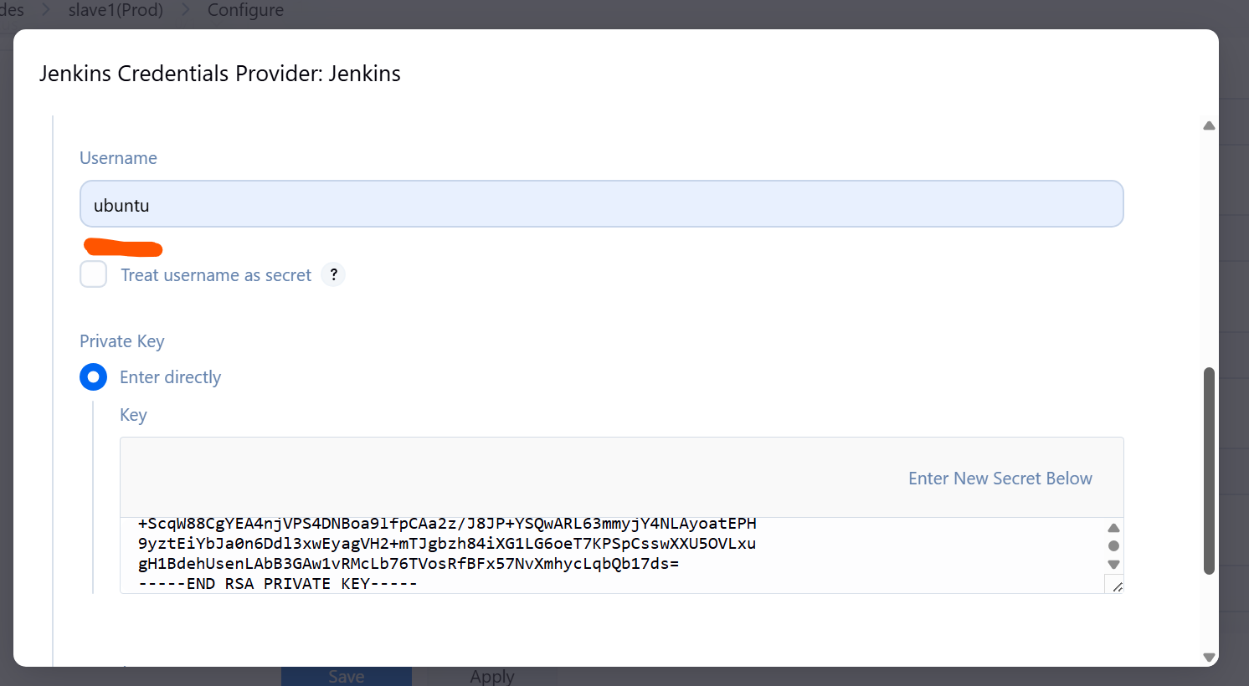and entry .pem file (private key)

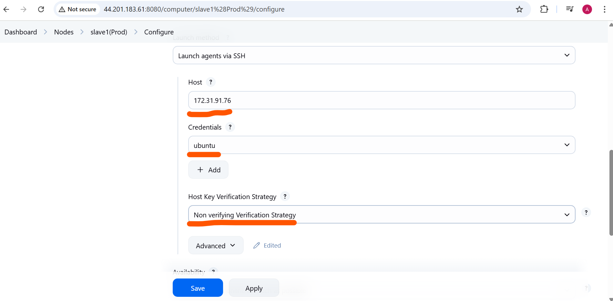

Now create new node for test

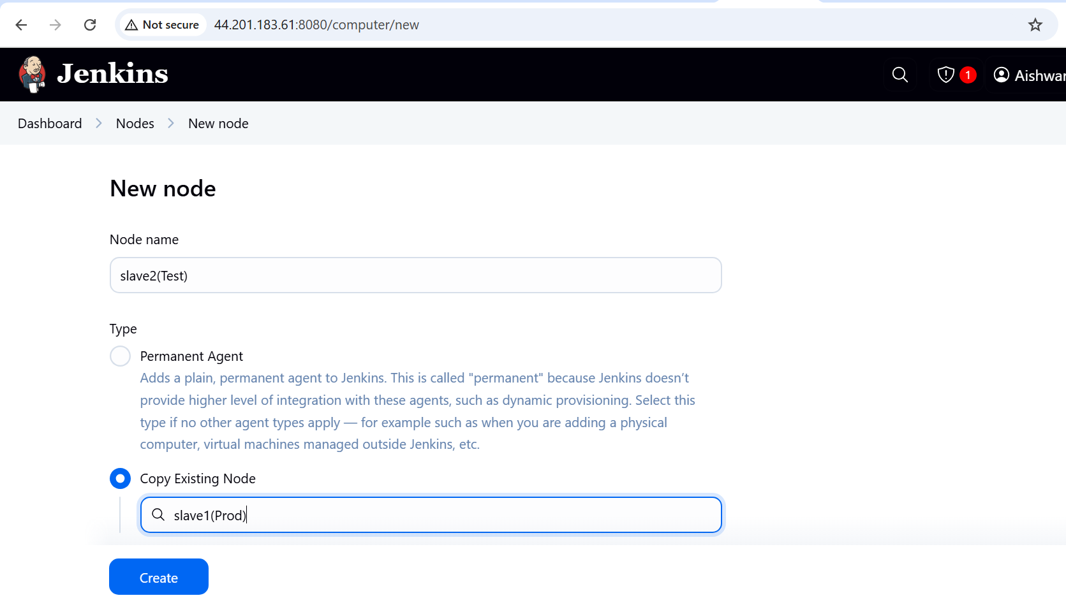

All nodes are connected

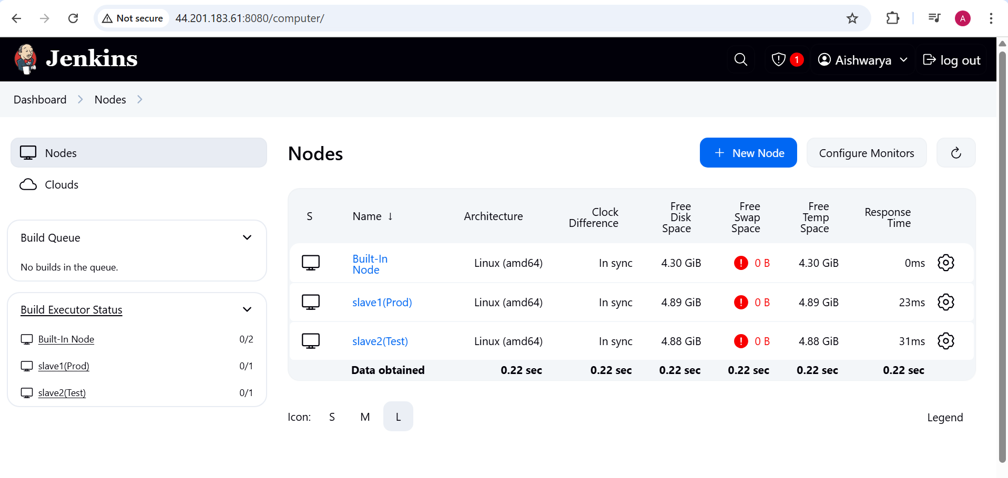

Now get the code

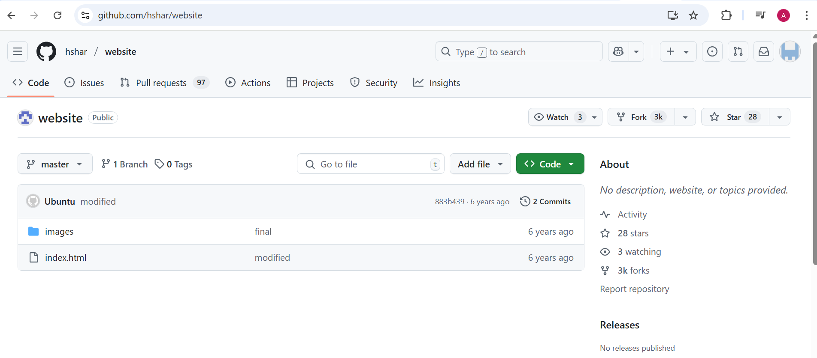Fork the repository

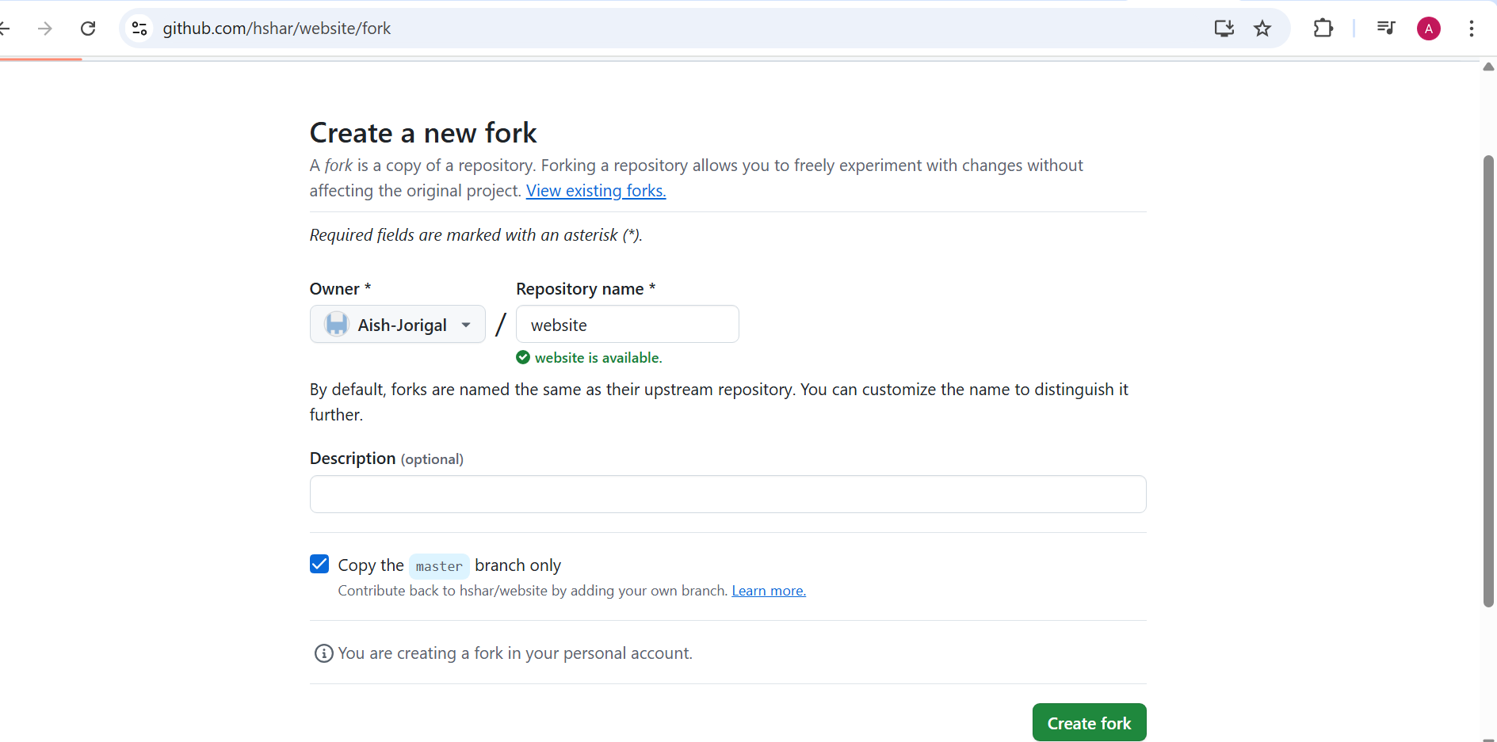

Create dockerfile

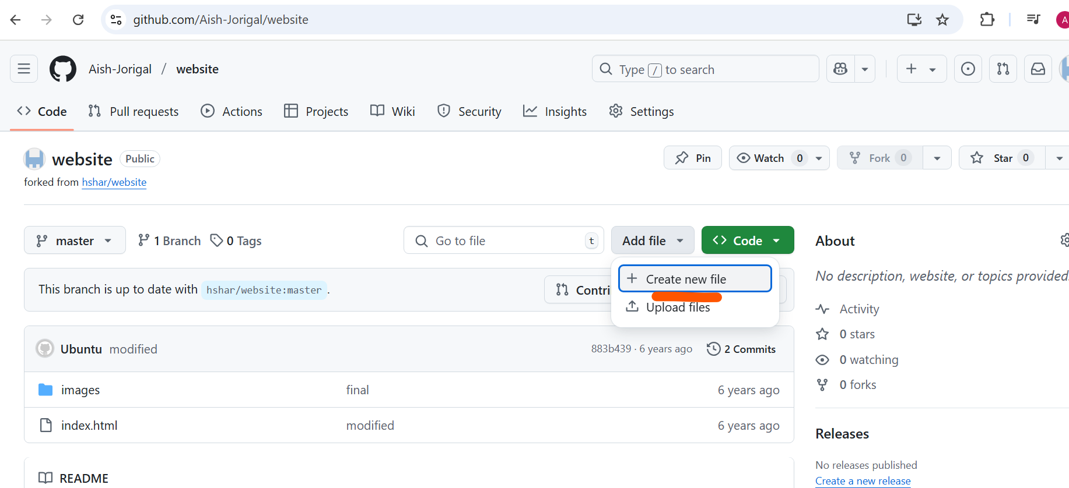

And commit the change

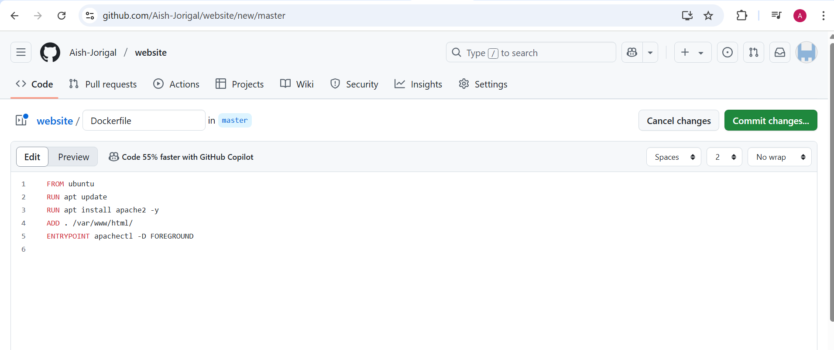

Now we have

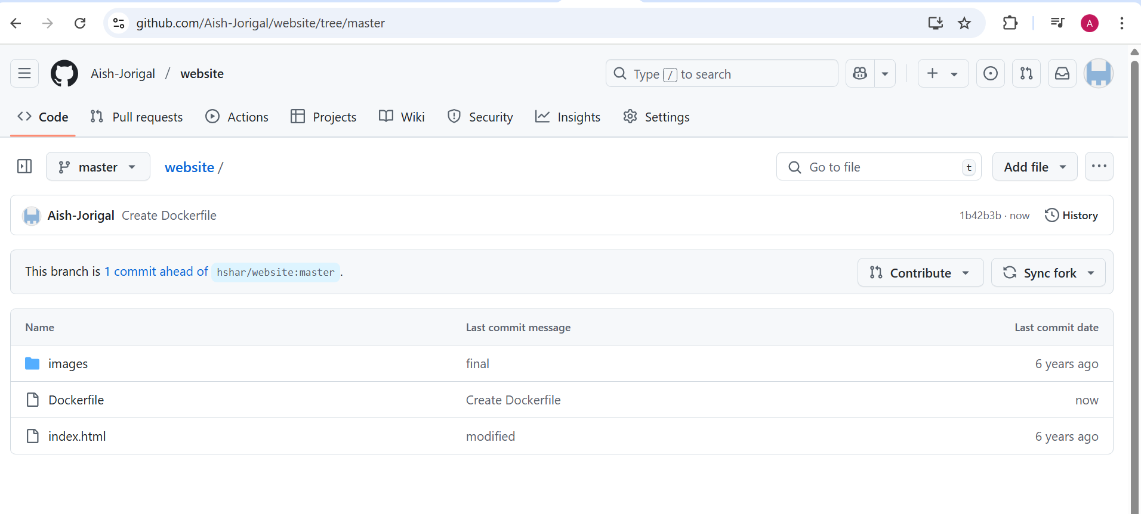

Create new branch develop

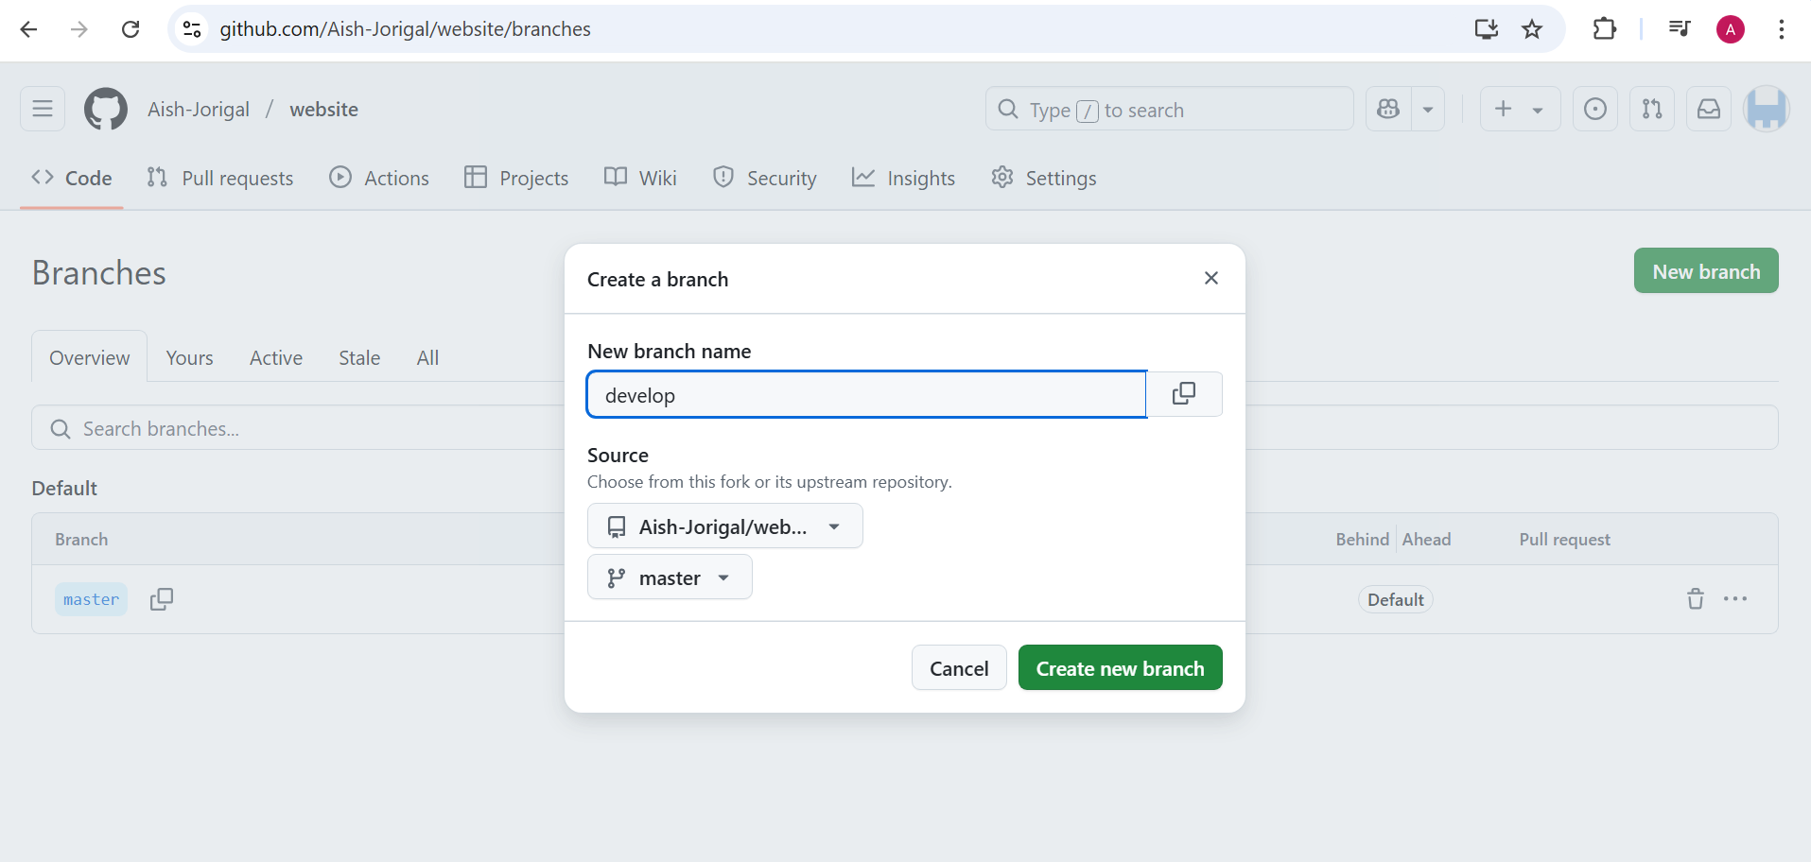

Enable webhook

Setting

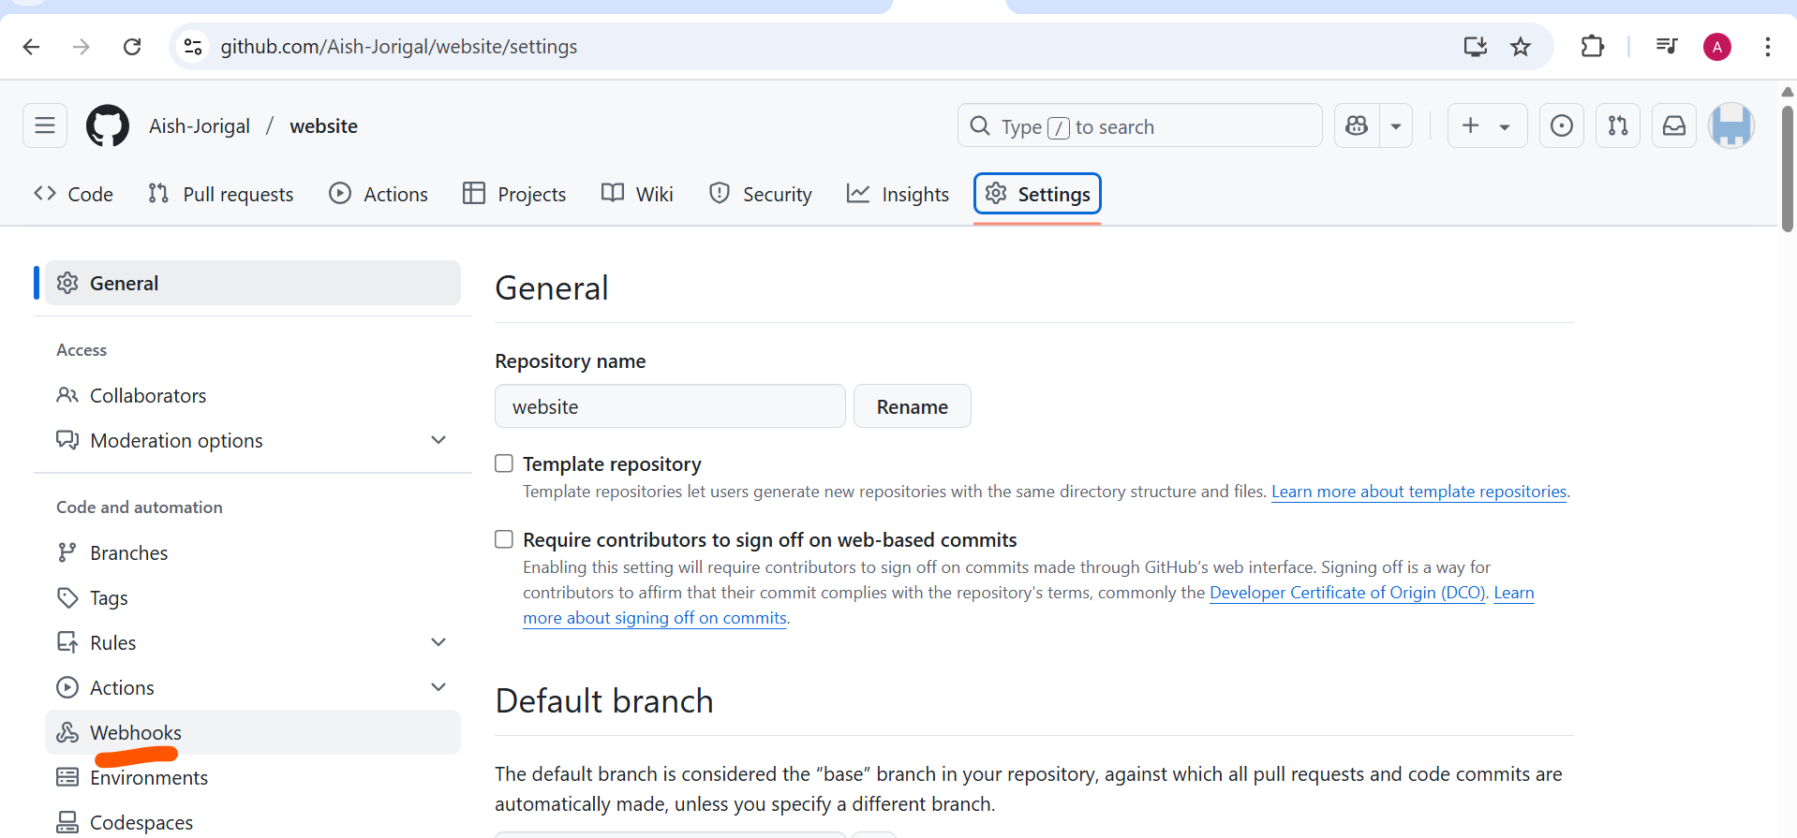

Add webhook

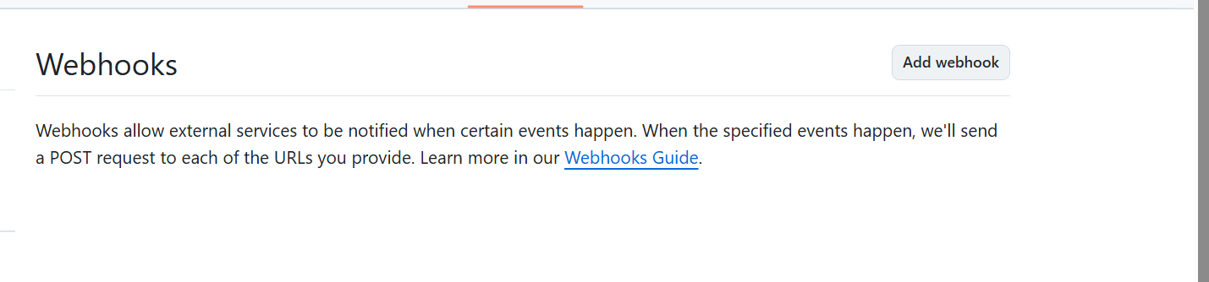

Add Jenkins URL

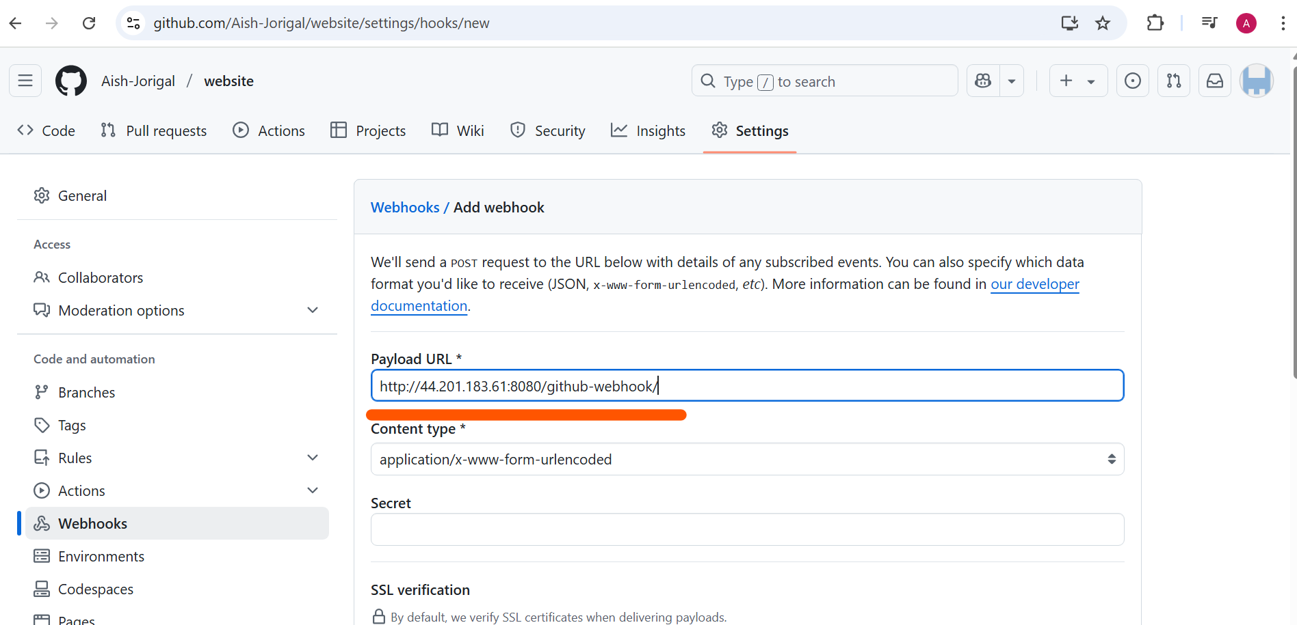

Webhook created

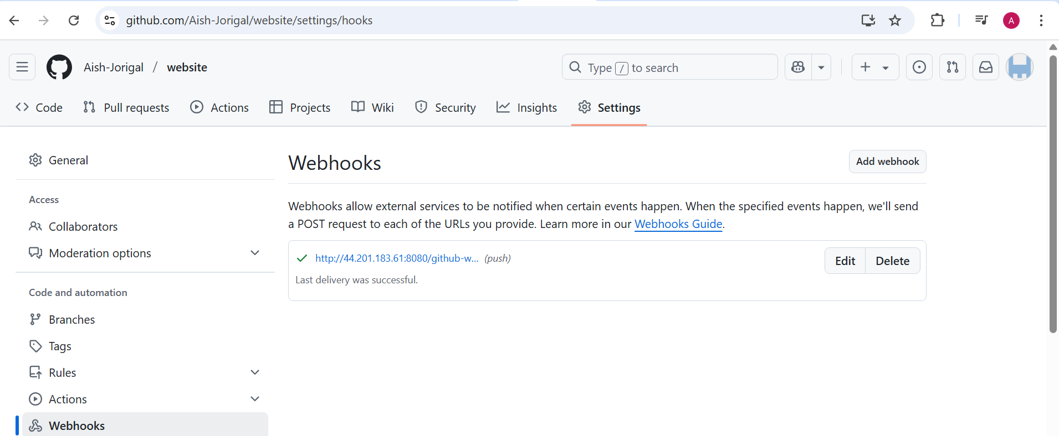

Now create job

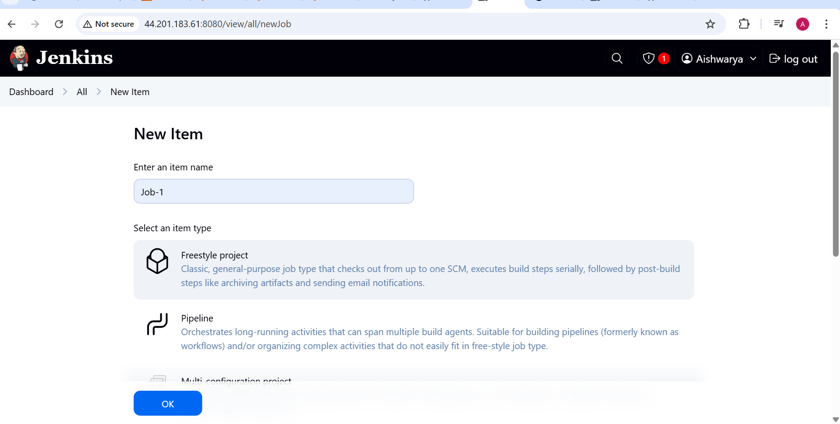

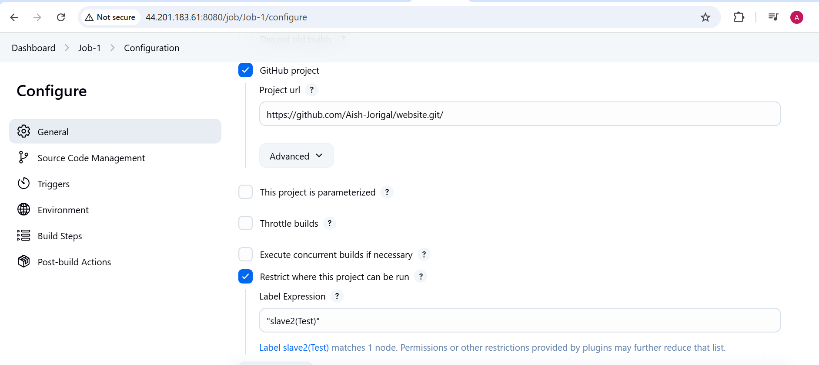

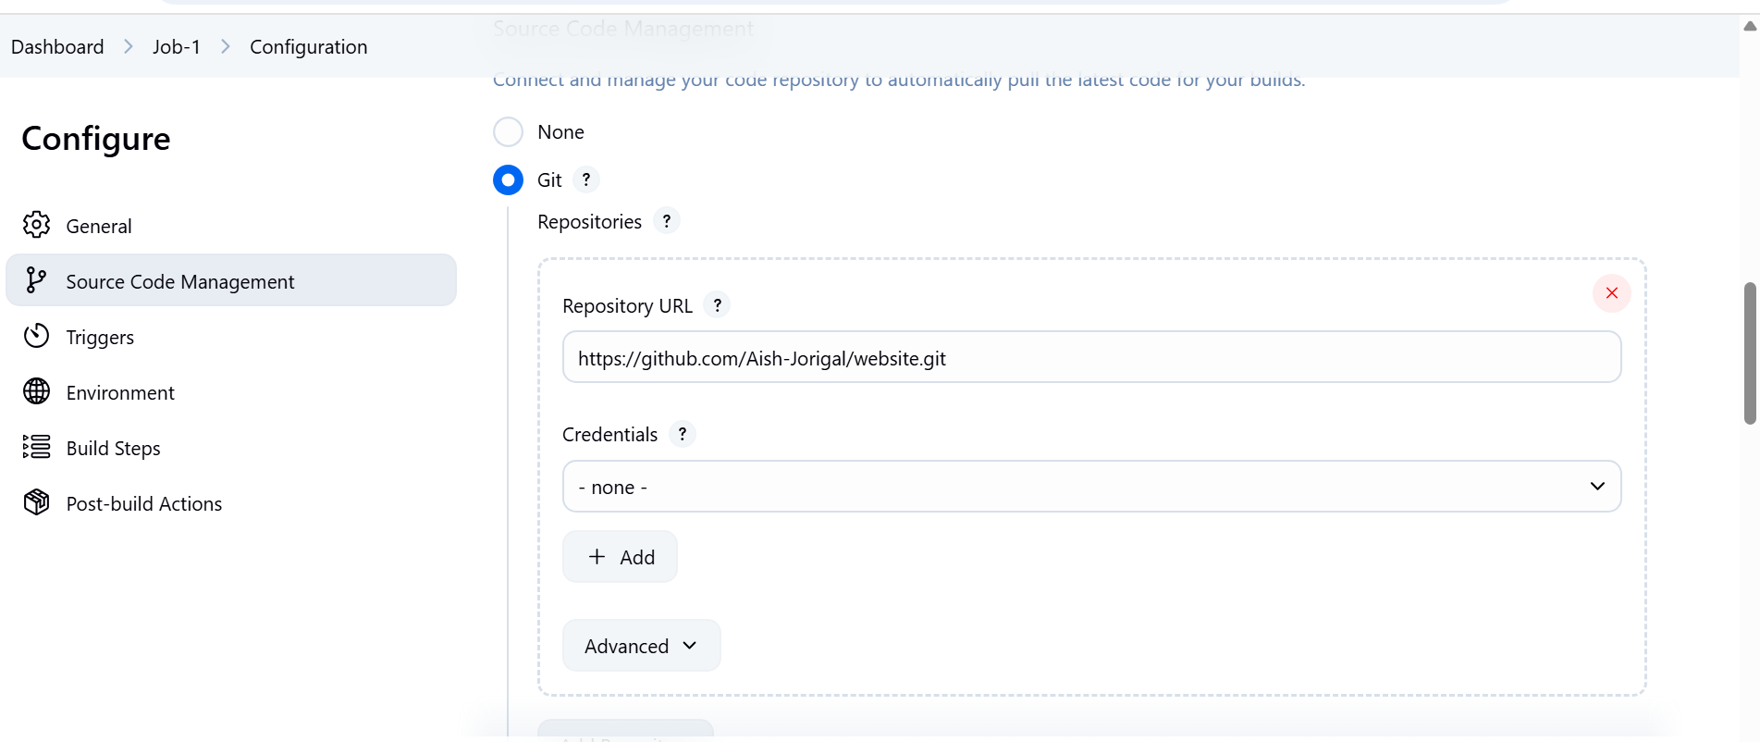

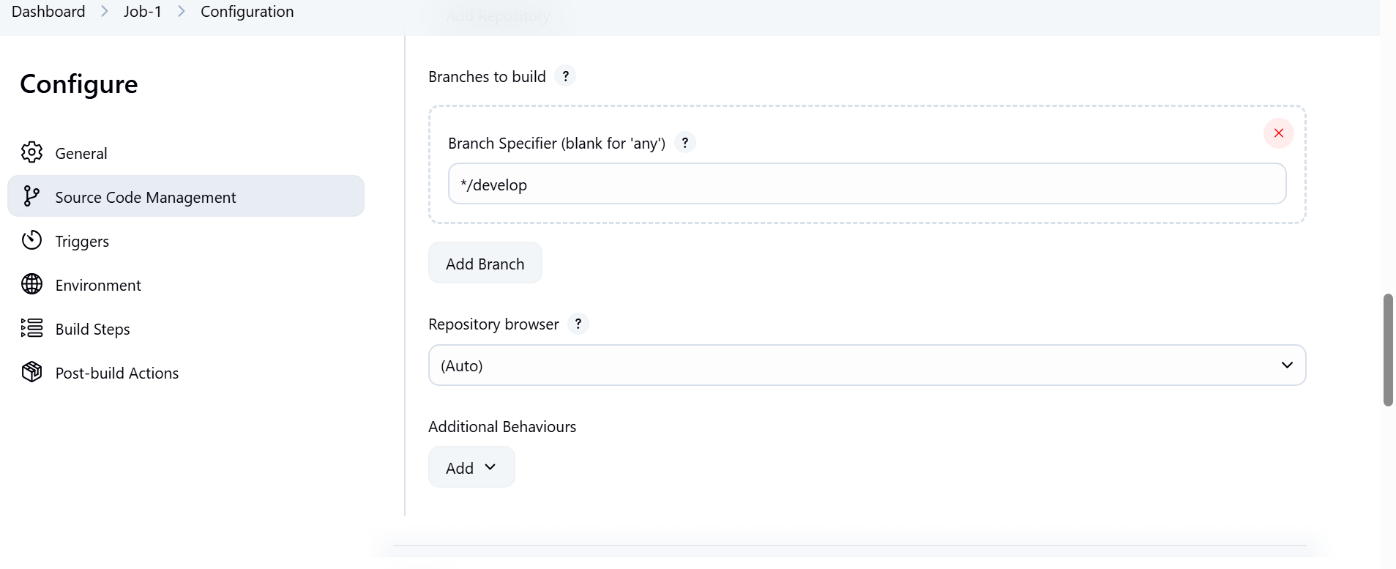

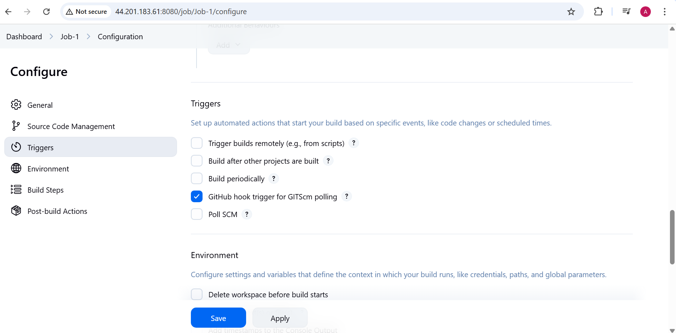

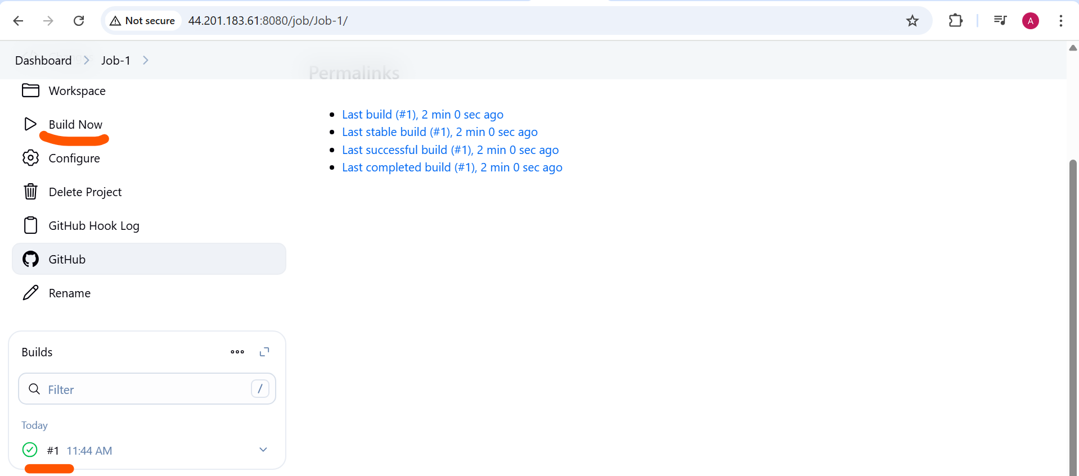

Create job2

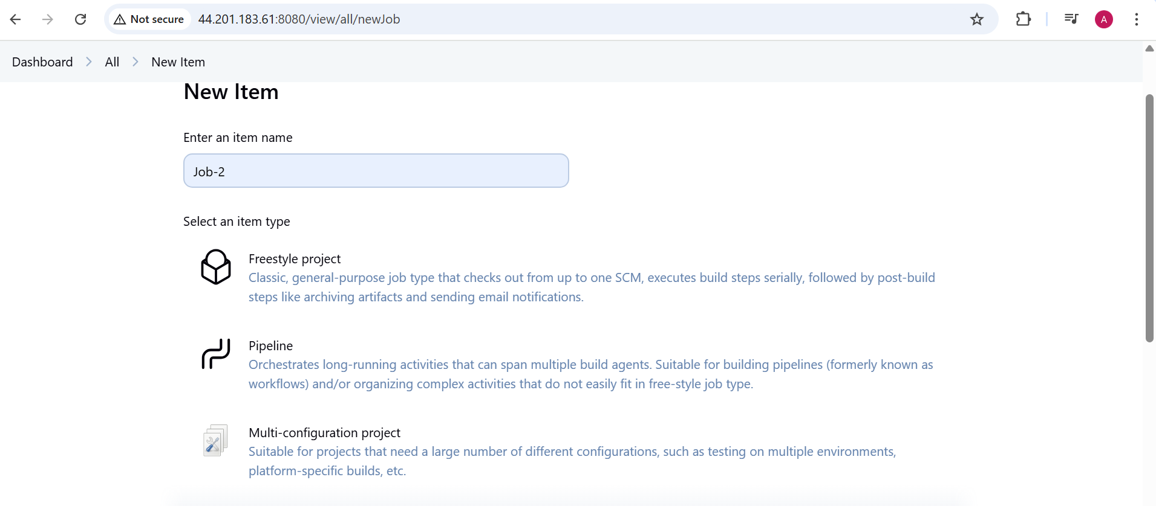copy from Job-1 only need to change the branch from develop to master

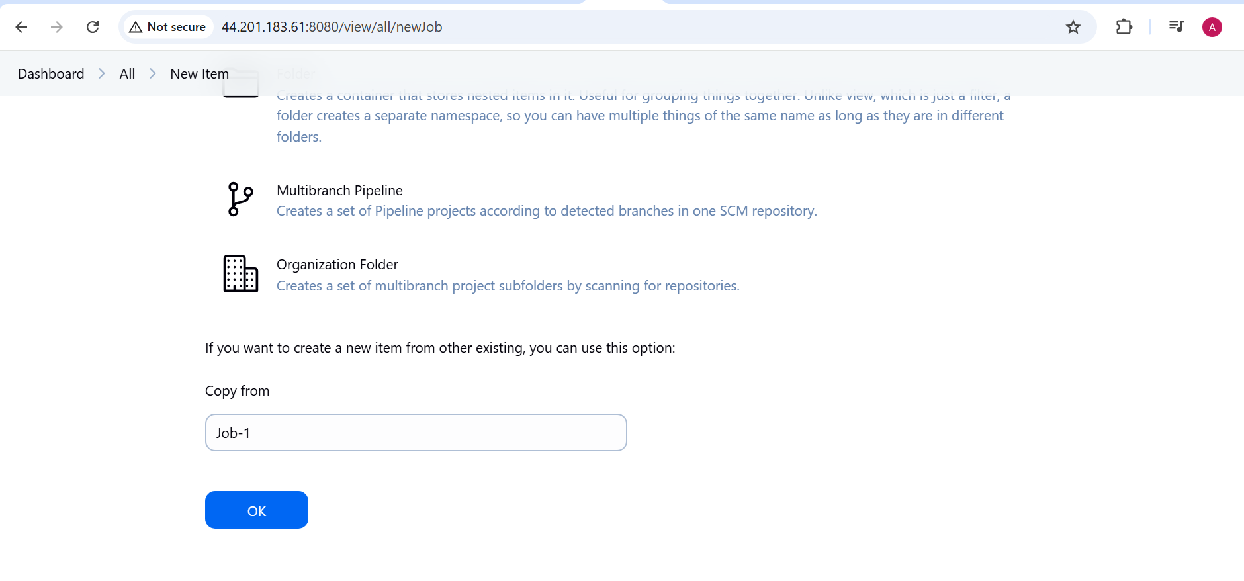 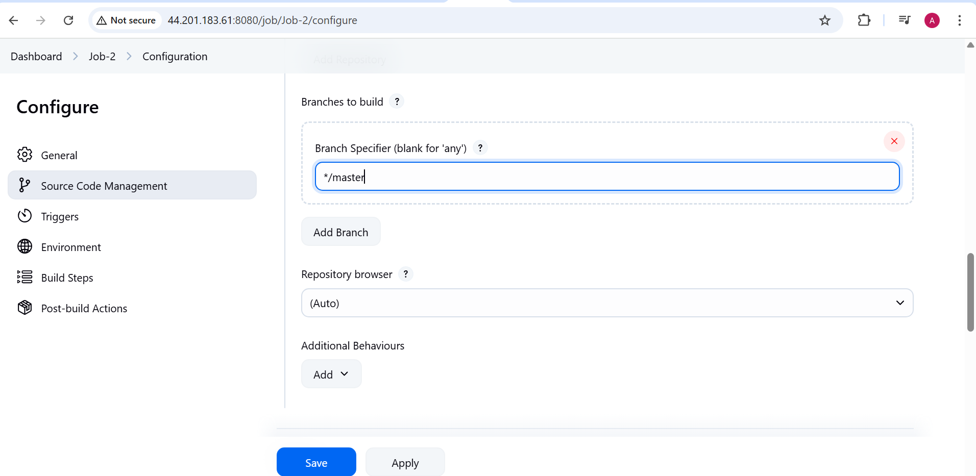

Build now-

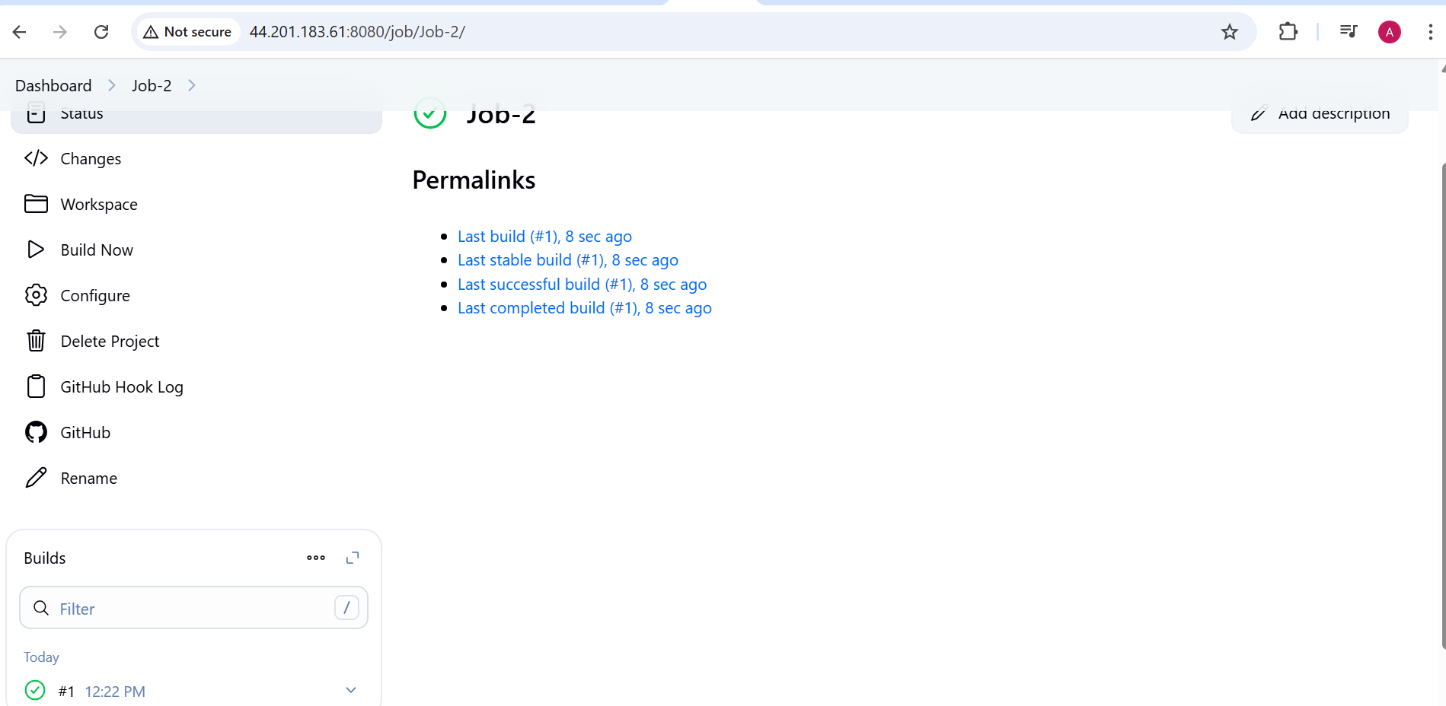

Now create Job3

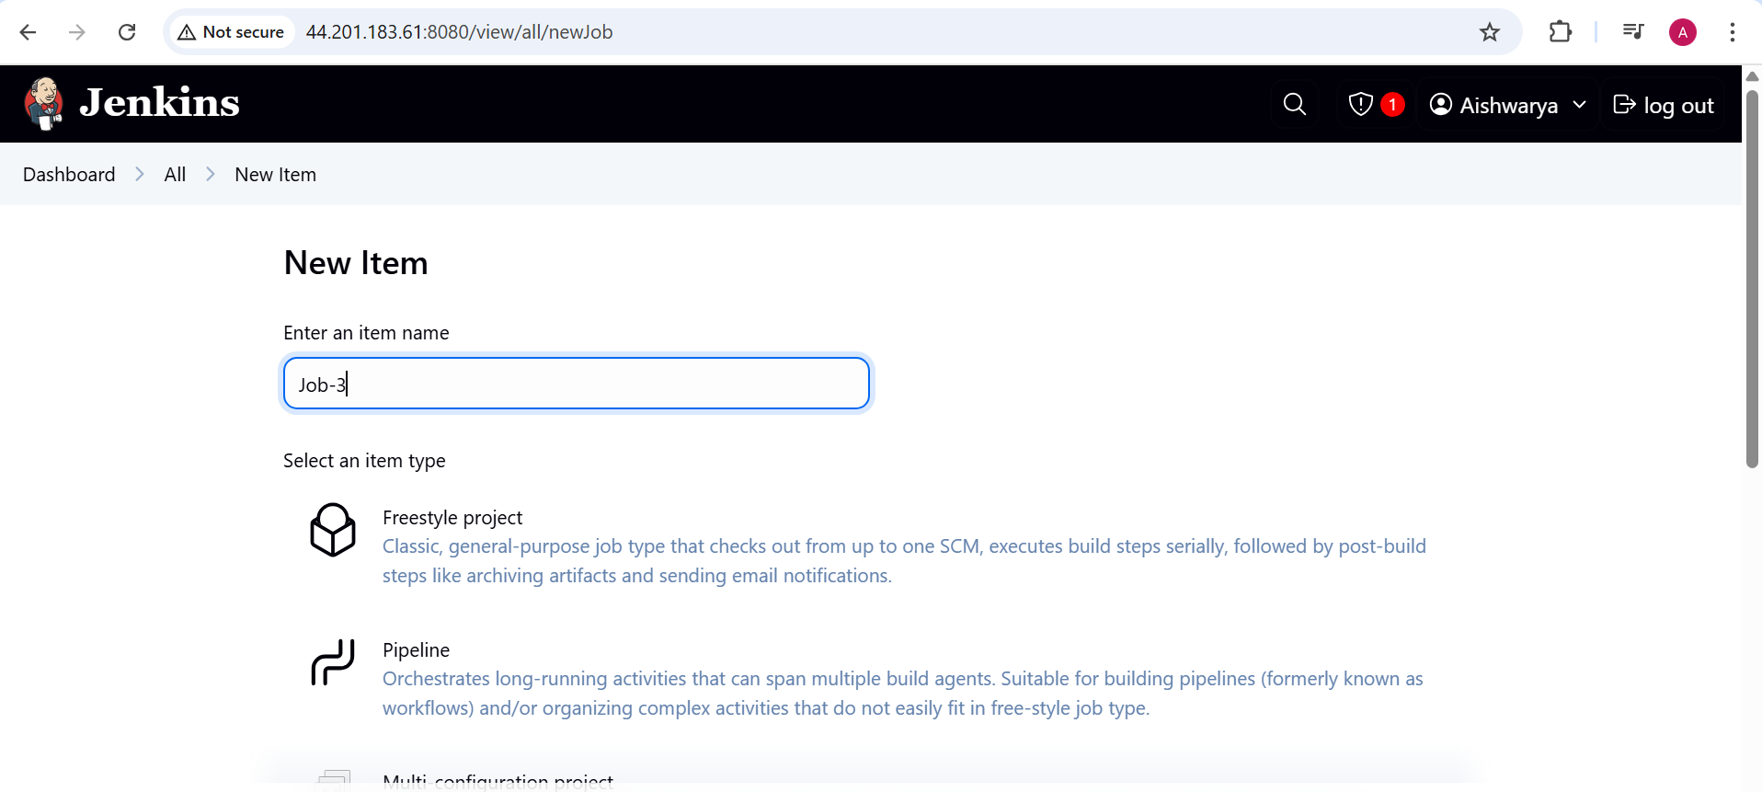

Copy from Job-2 only need to change slave1

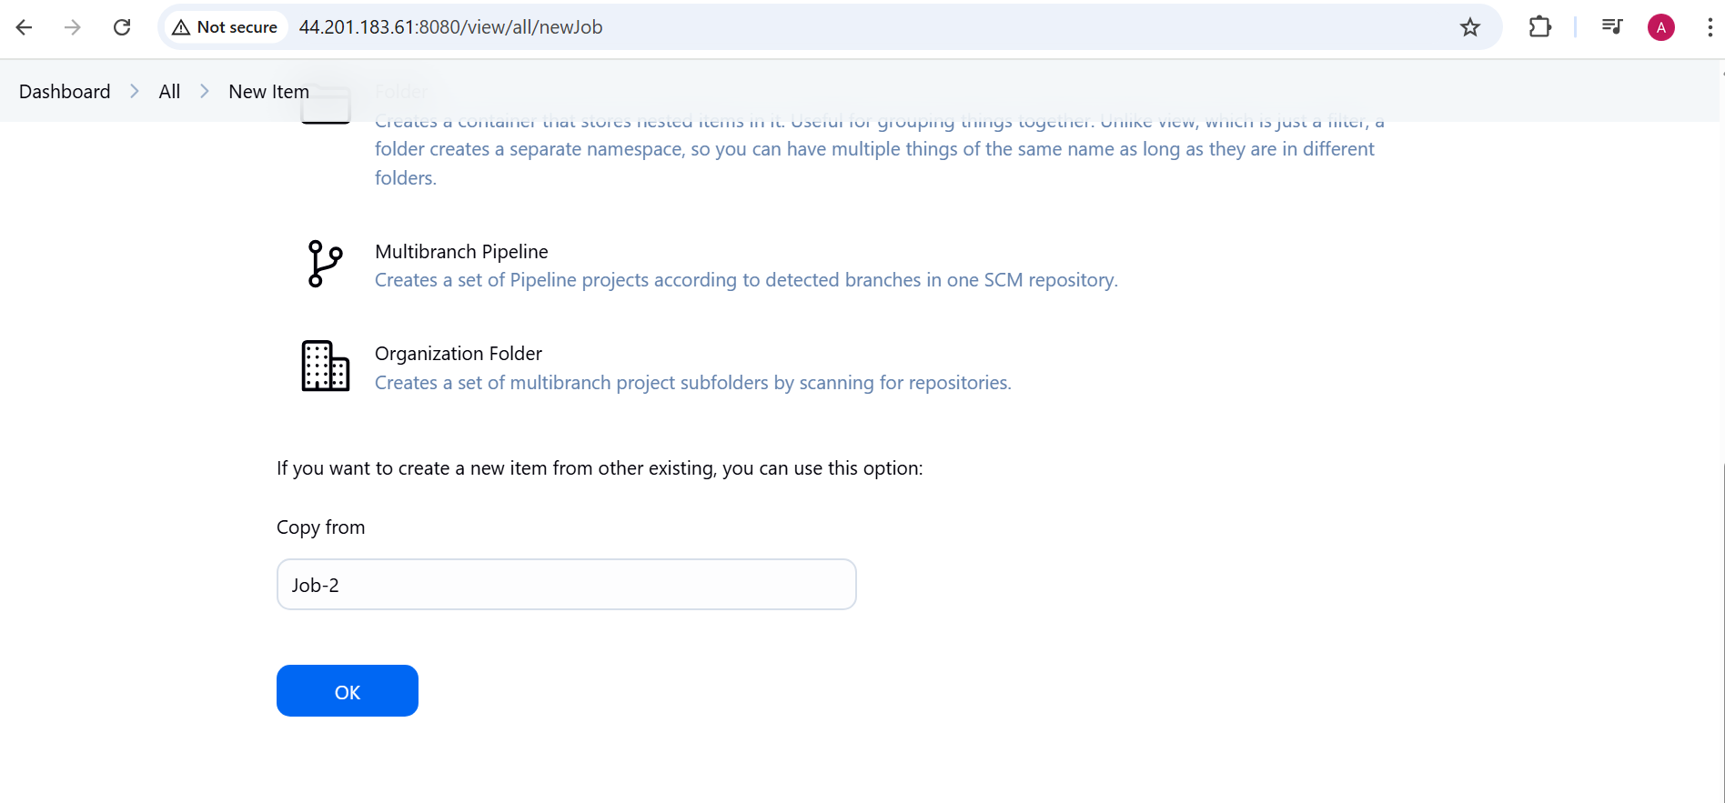

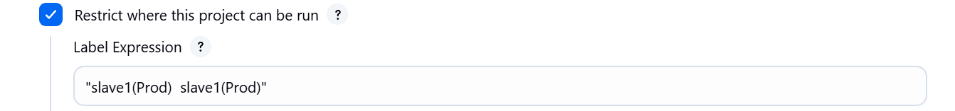

Build Now;

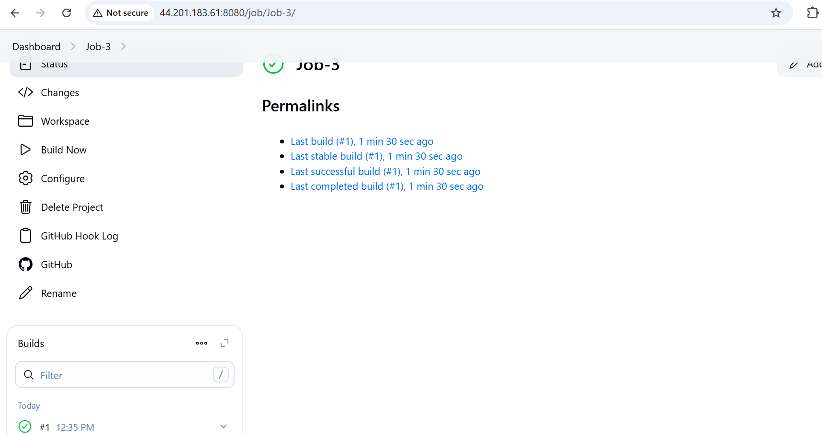

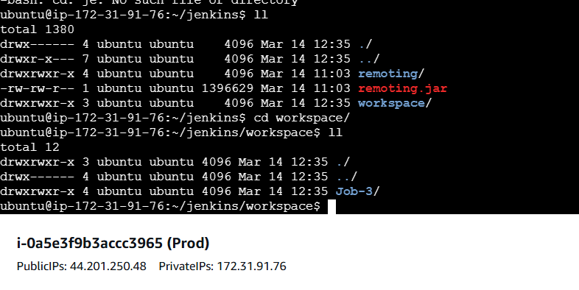

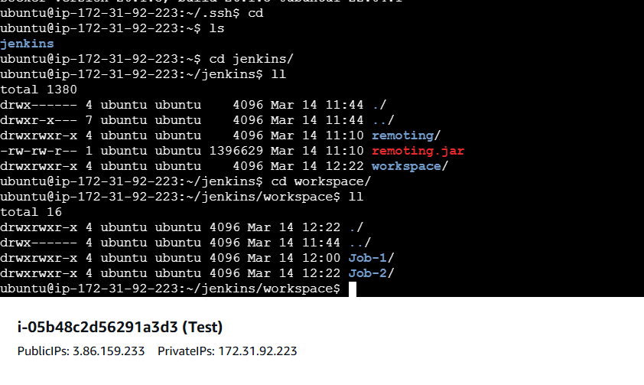

Now dockerise the application

JOB1 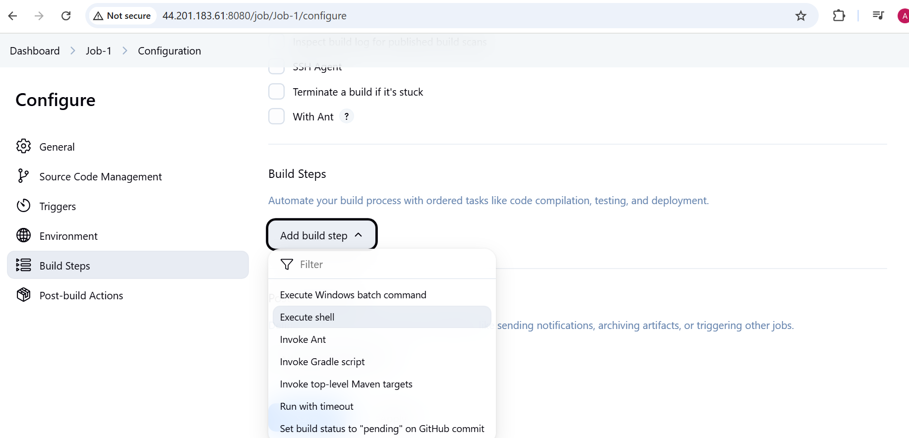

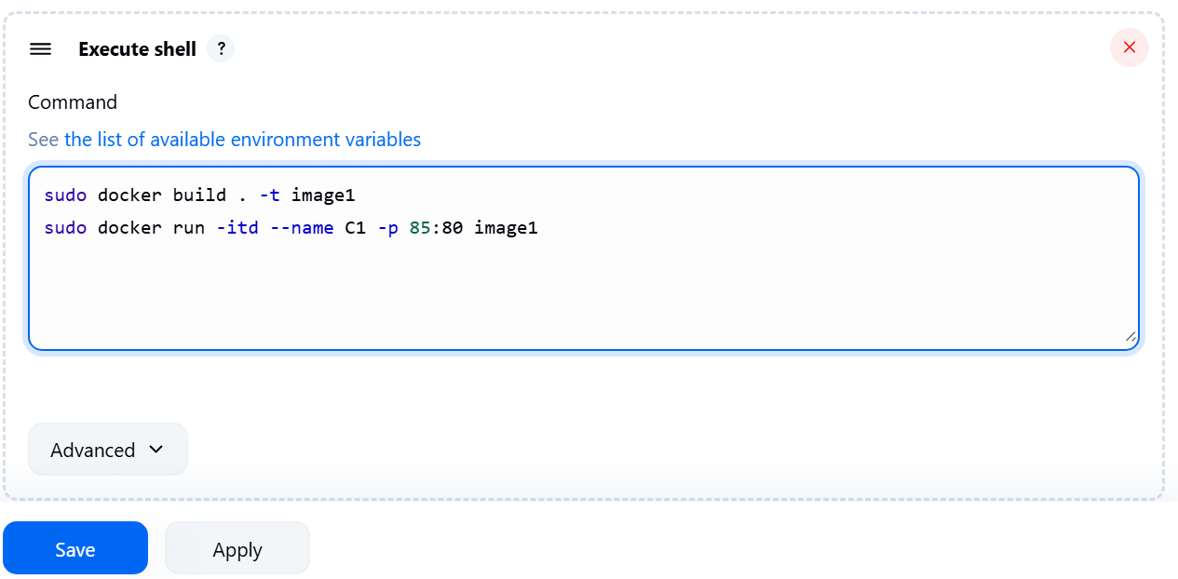

Build now:

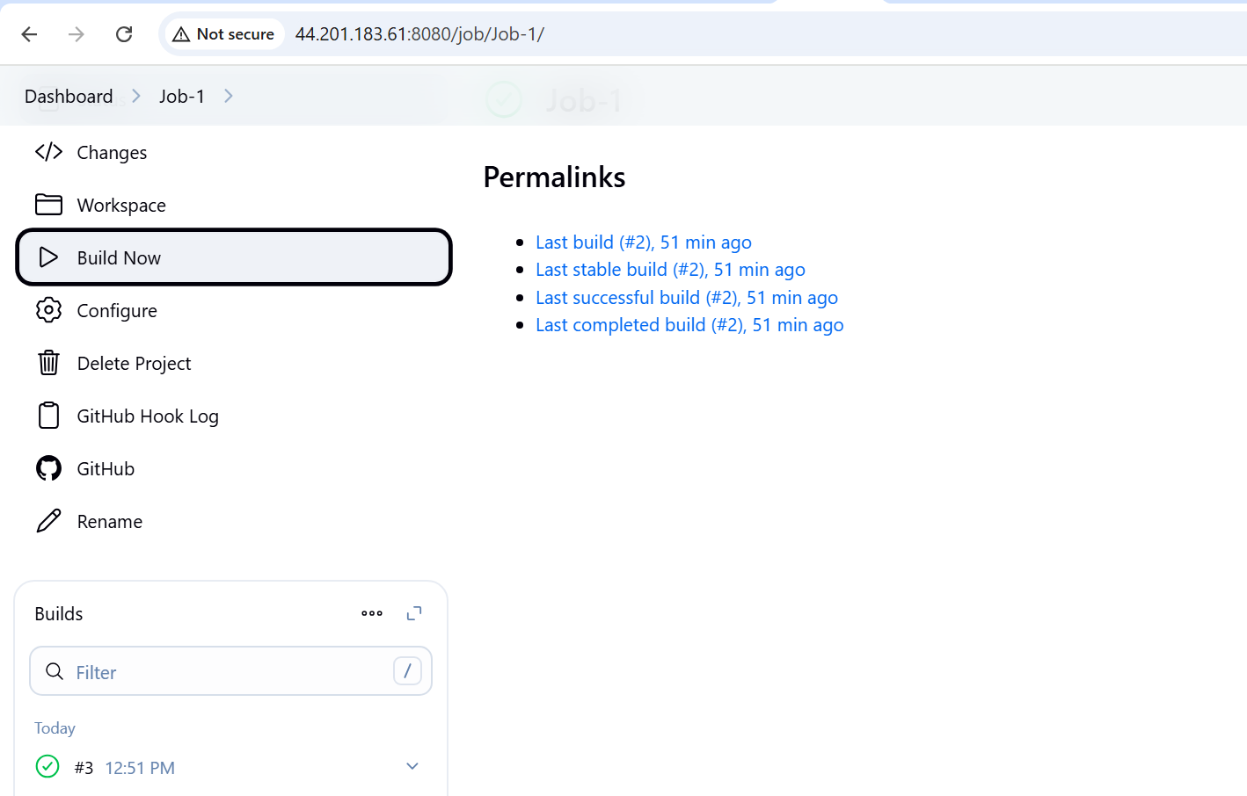

Take the public Ip of machine which is configured for this Job and put the port which is used in the run cmd

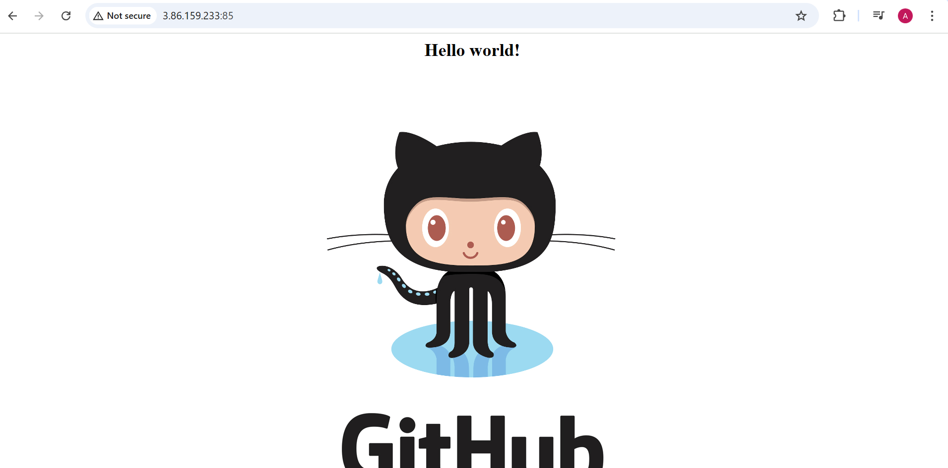

for future:

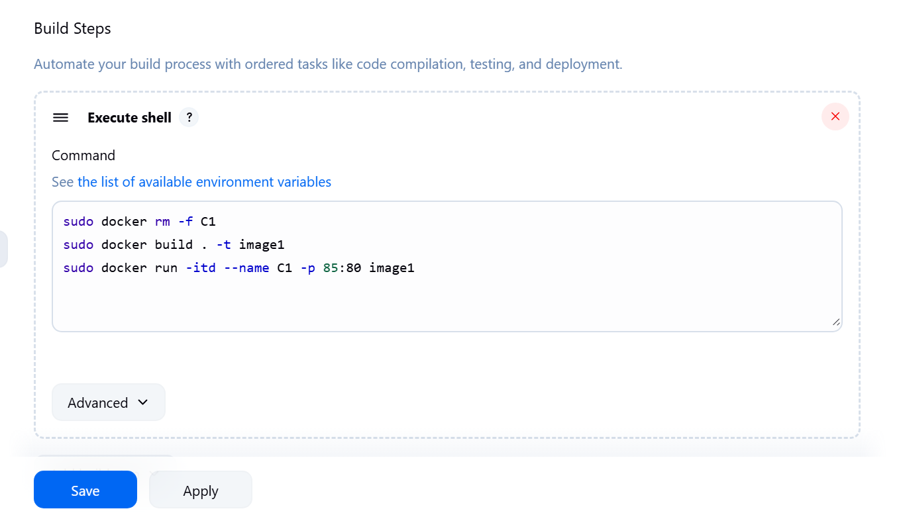

Updating the index.html to check webhook

